Lachine Concert Band
Inventory Status September 21, 2020

Item | Image | Condition | Status
Amplifiers:  - Fender Rumble 25  - Roland KC?  - Polytone 101 | 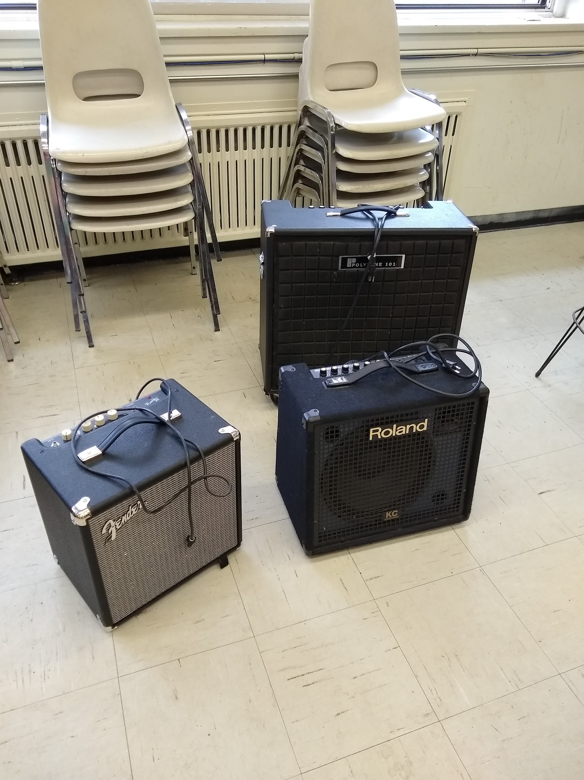 | Good. Except the Large Bass amp needs repair. | Fender returned to Stanley  Roland & Polytone stored at Ivan’s
Baritone Ambassador | 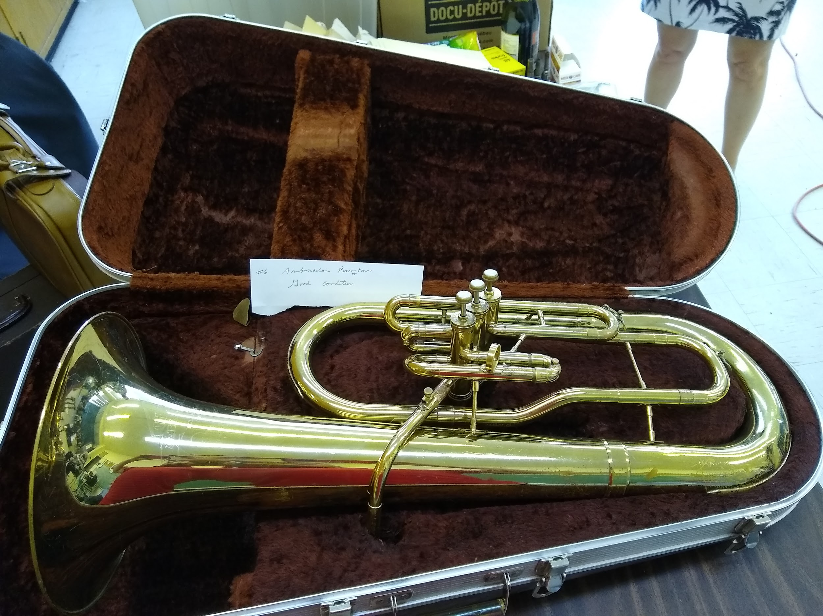 | Good | Sold  $200  Kieran Cabana
Baritone Sax 9 | 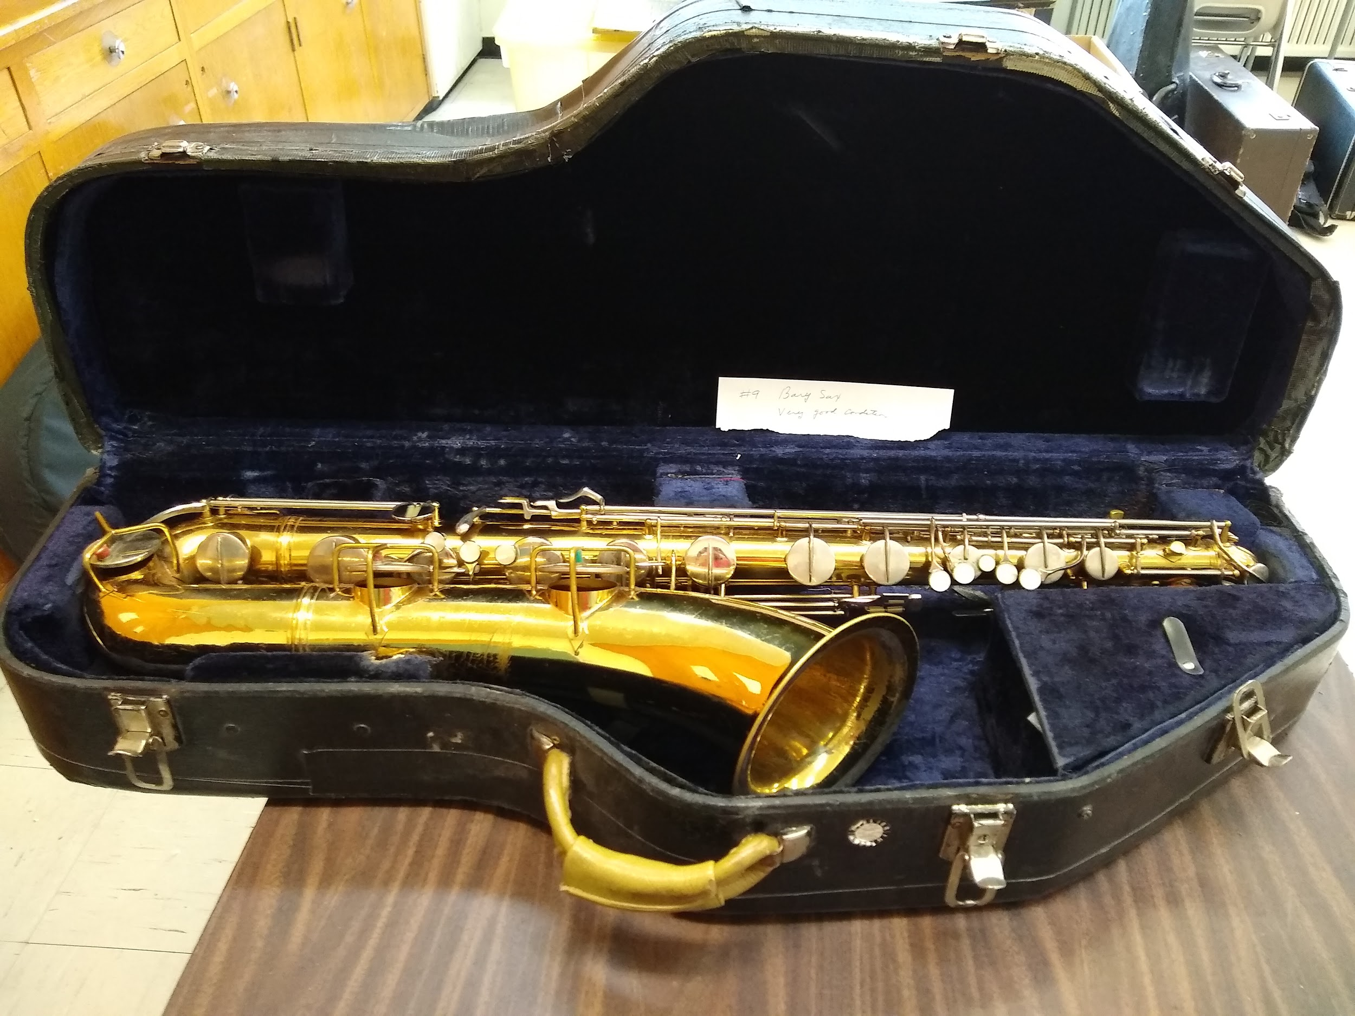 | Good | LCB - Stored at Ivan’s
Baritone Sax | 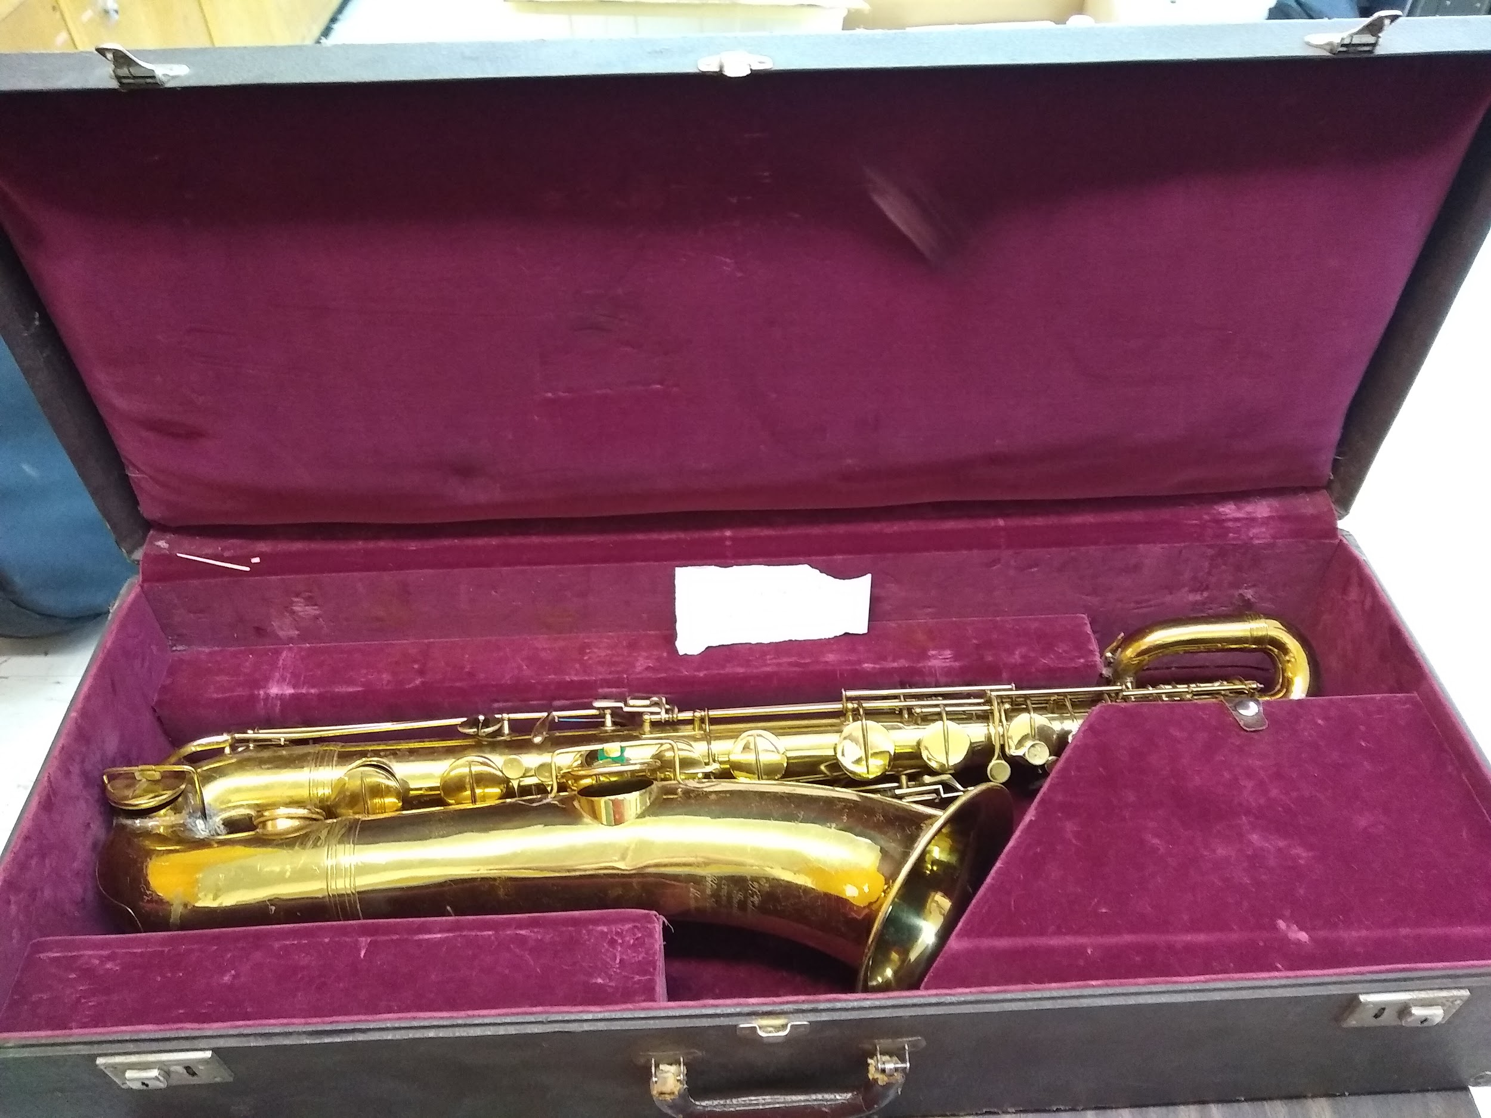 | Needs repair | Loaned to Micheline Plante
Bass Drum and tenor drum | 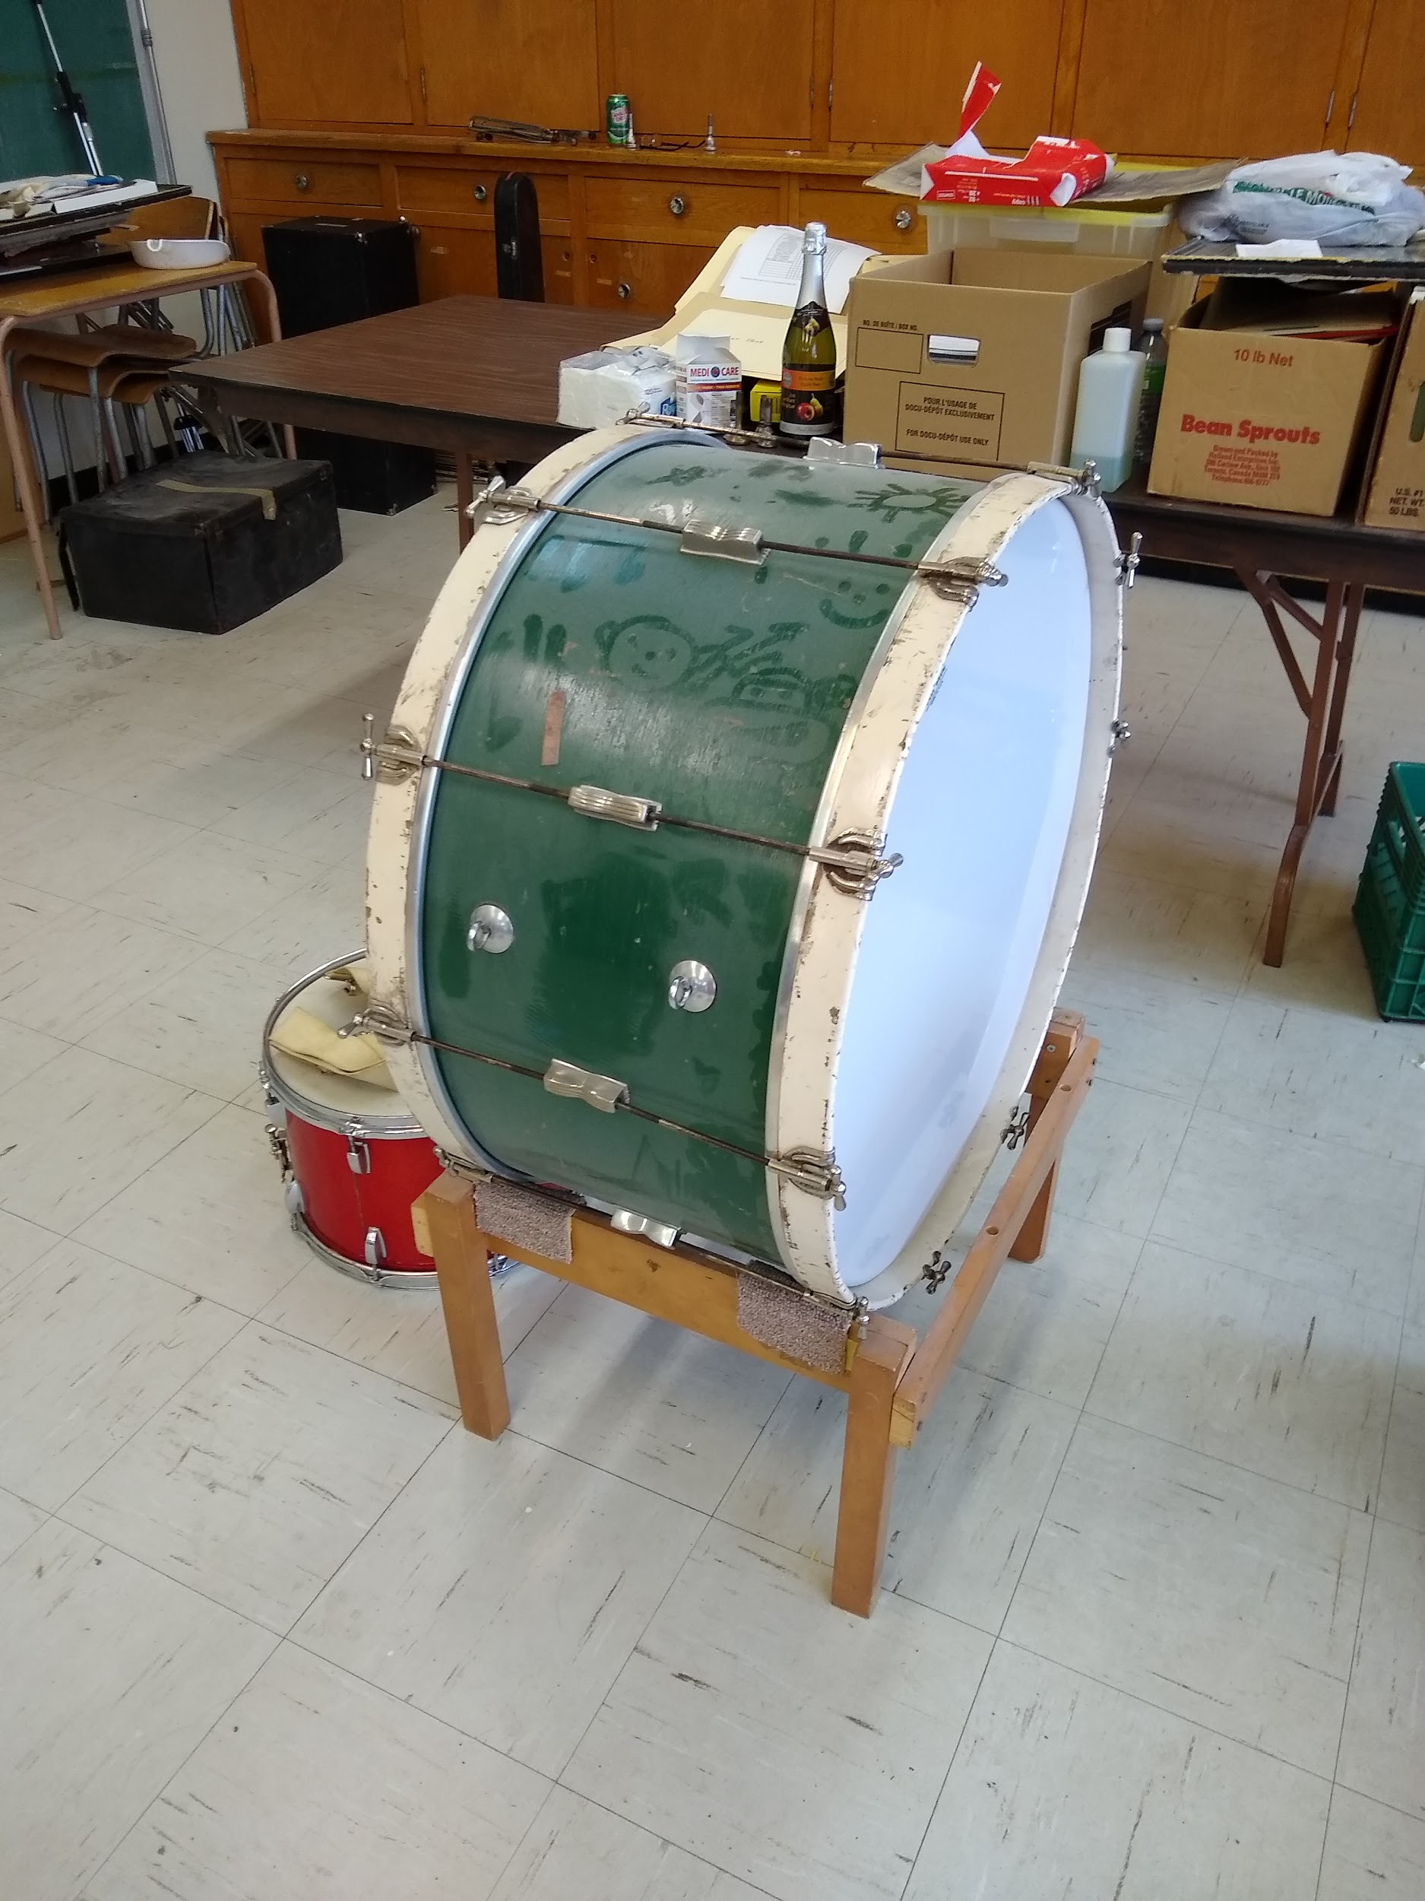  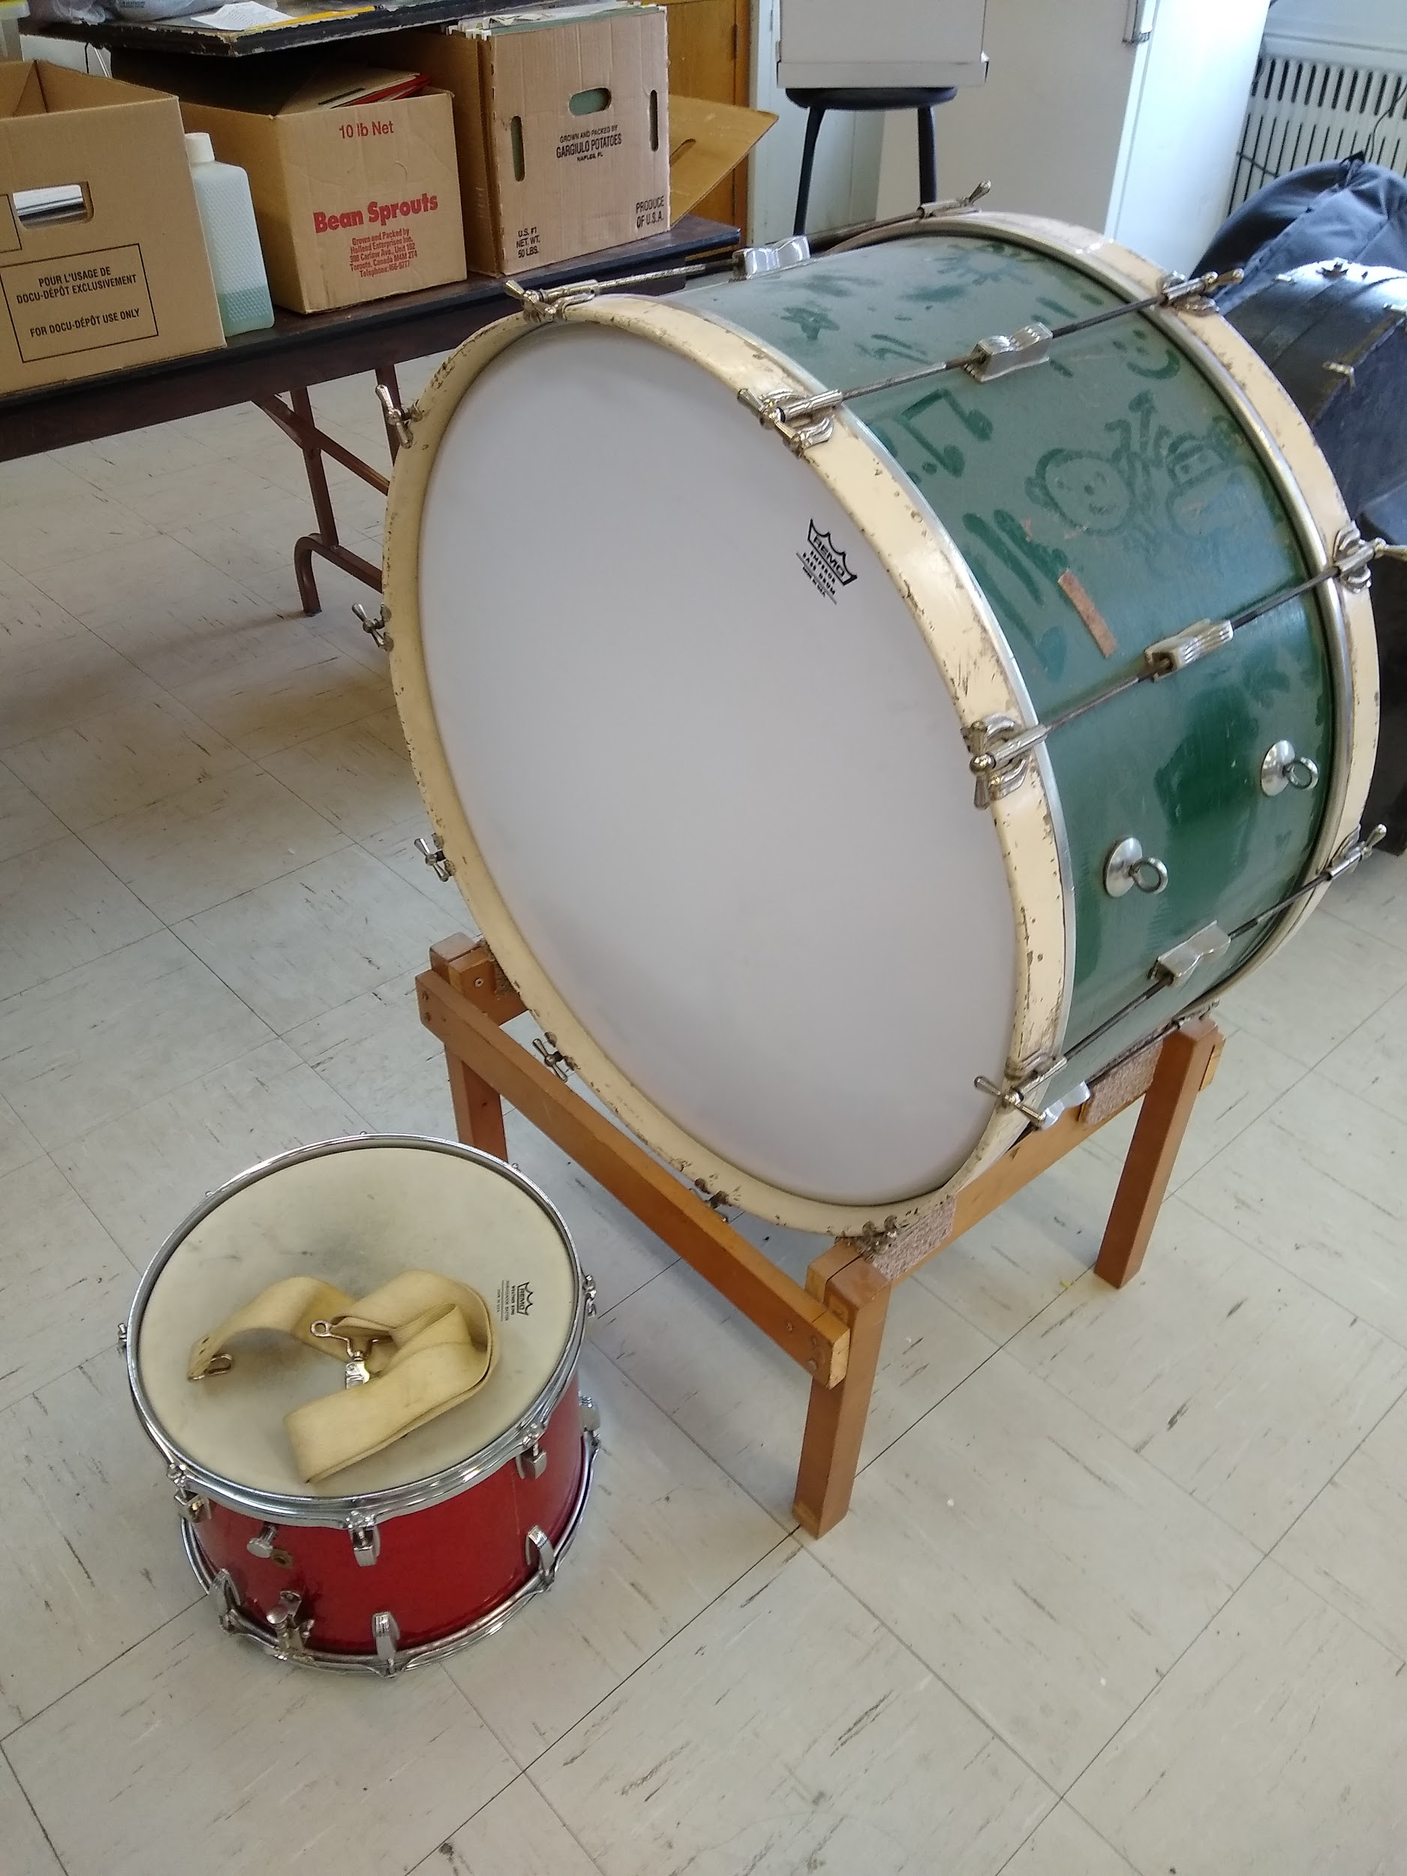 | Good | Sold  $50  Elizabeth Huyer
Bassoon Cabart | 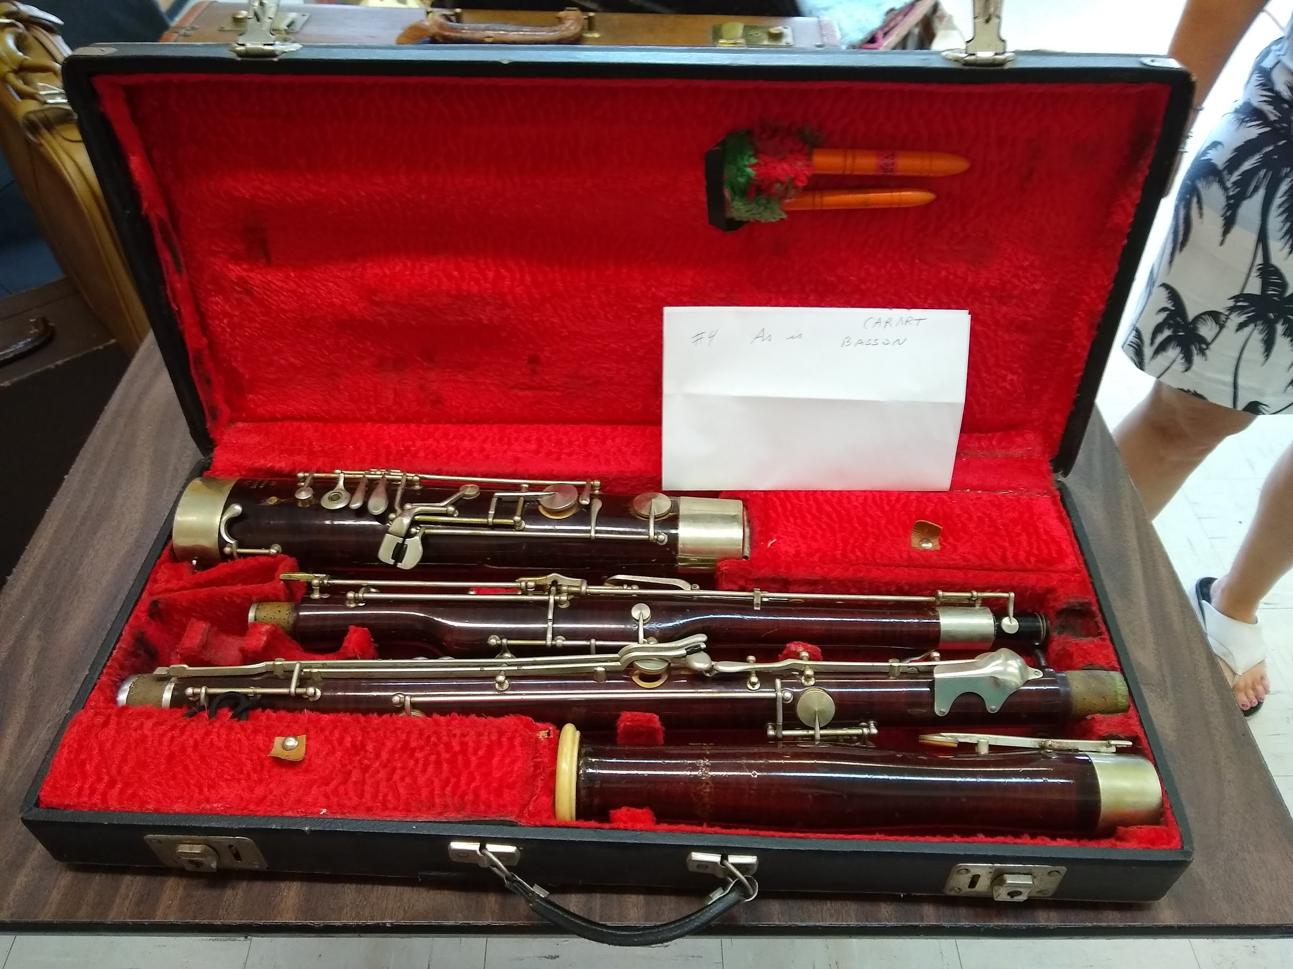 | Needs repair | To use for parts only (missing keys)  Kerry will ask Steve Dubinsky
Boom mic stand - Realistic |  | Good | Stored at Kerry’s
Christmas Decorations | 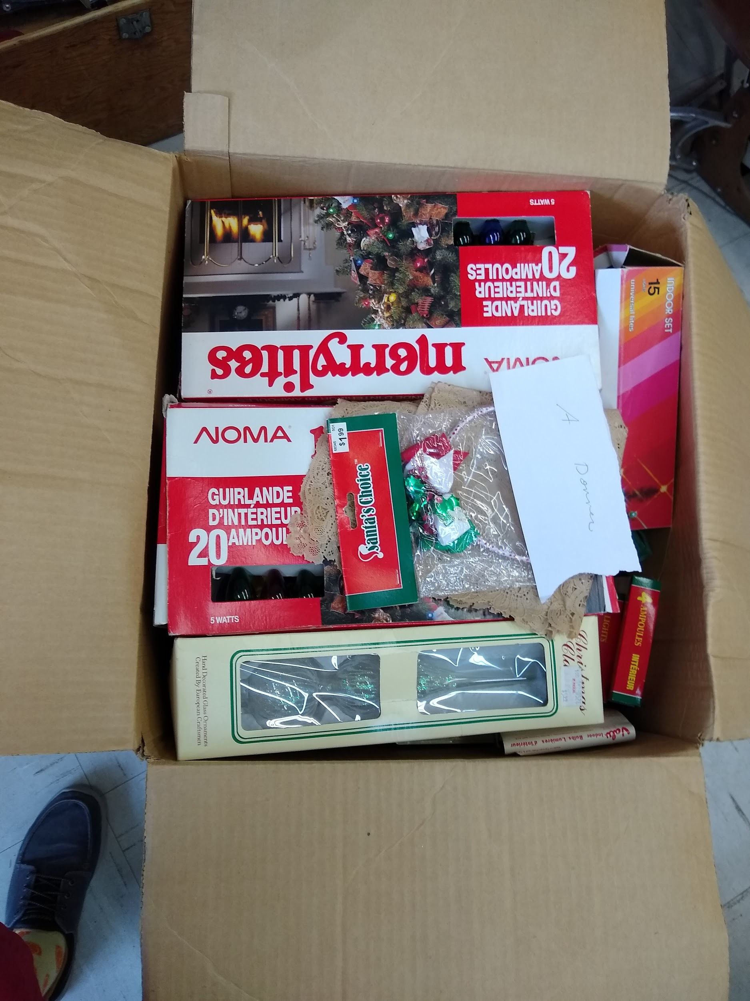 |  | Discarded
Drum Set and Percussion | 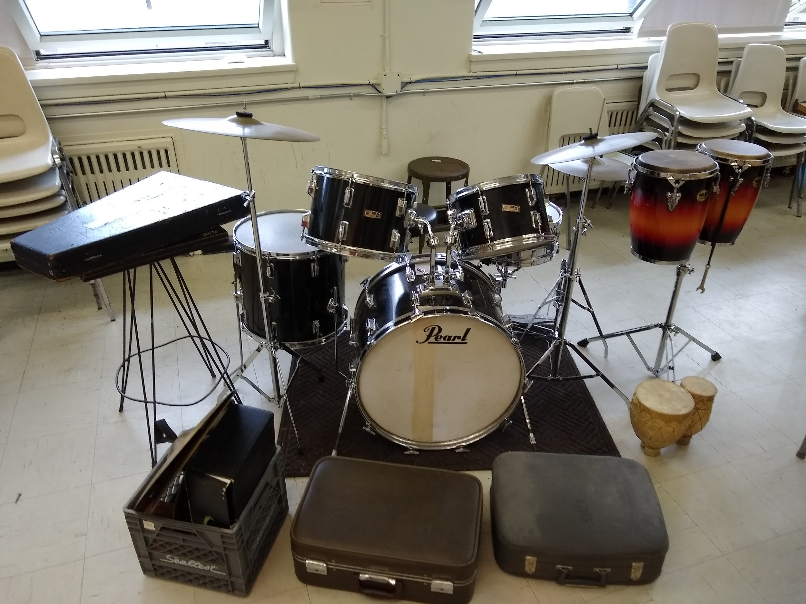 |  | LCB - stored at the Entrepot
11 Filing Cabinets | 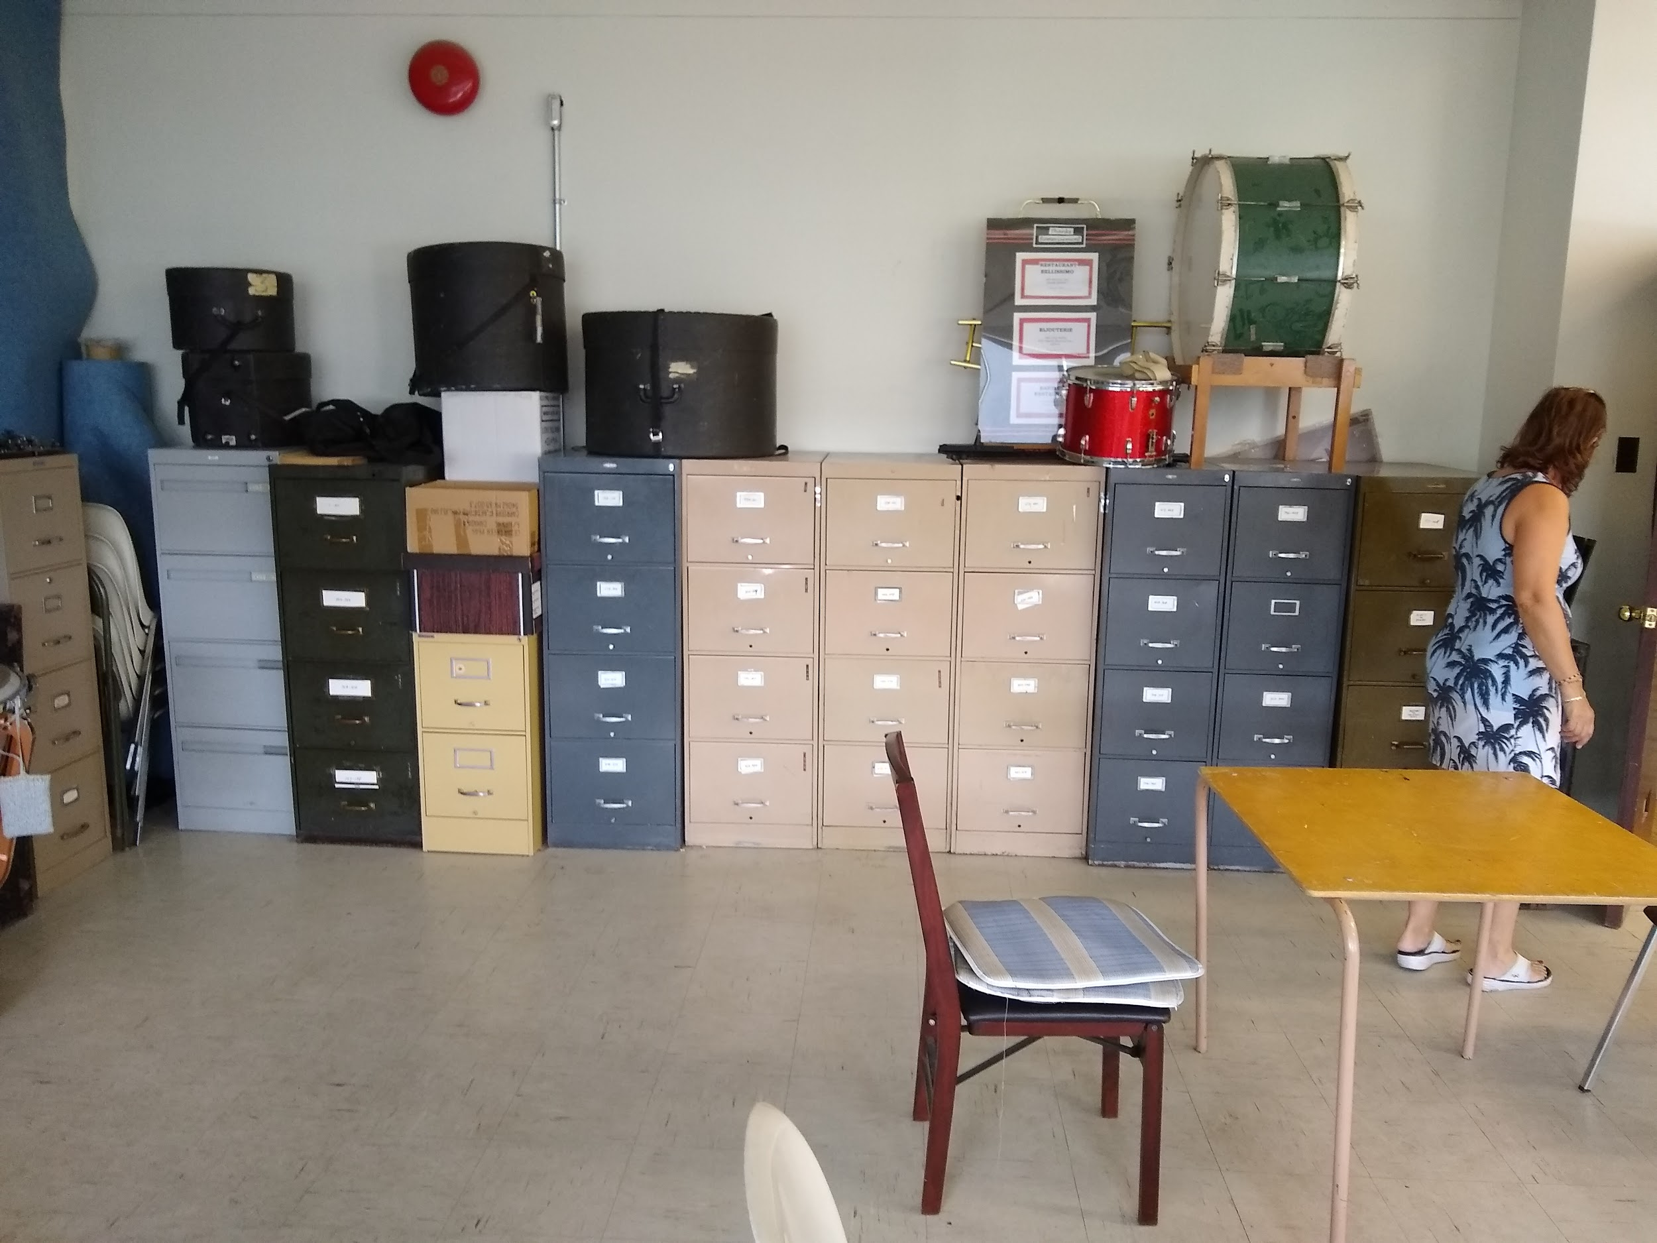 | To be evaluate when music is all sorted | LCB - Stored at Ivan’s
French Horn 2 | 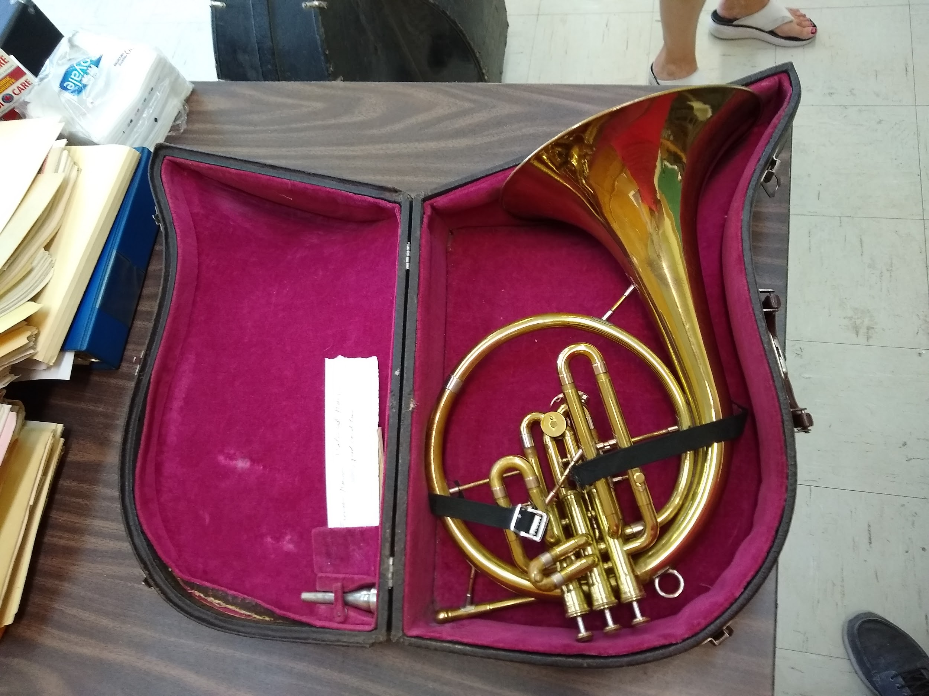 | Good | Sold  $100  Susan Bellamy
French Horn 6 | 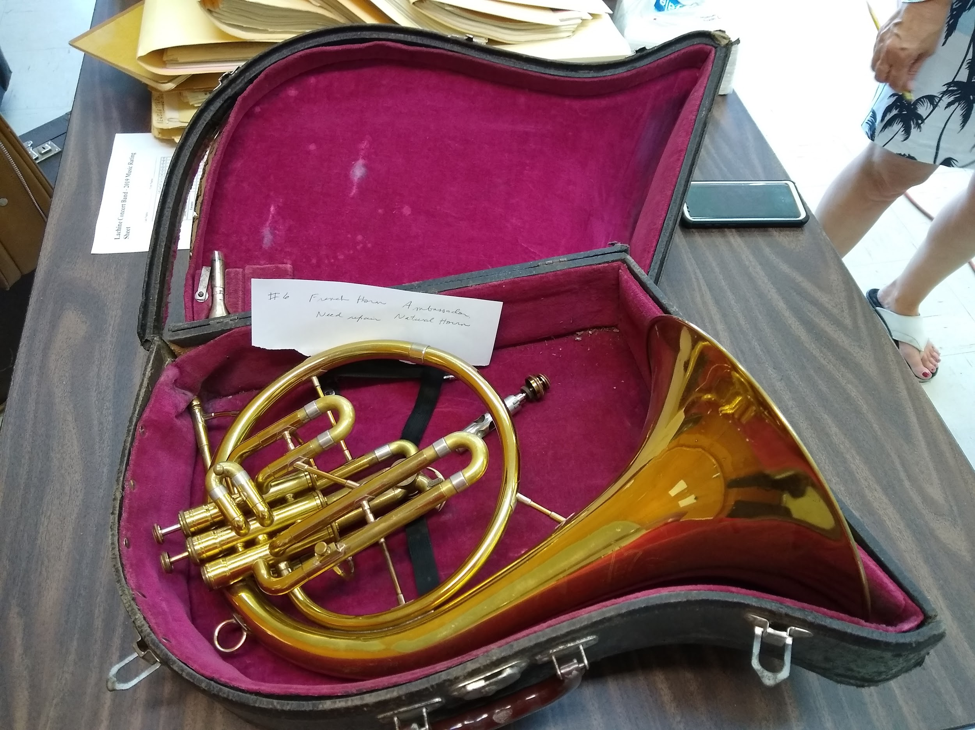 | Good | Sold  $100  Frank Everett
Fridge (without drinks) | 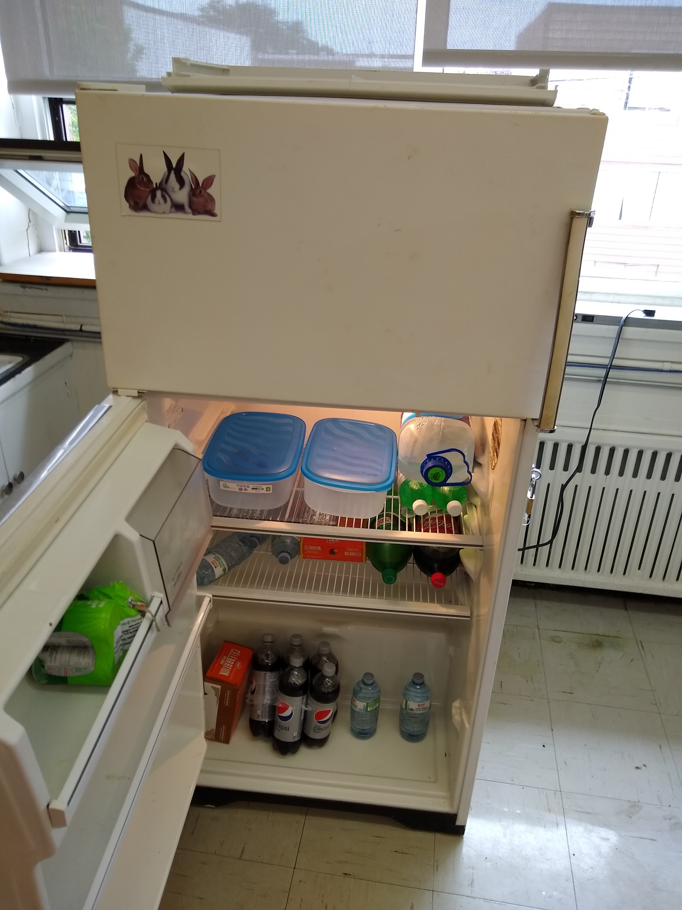  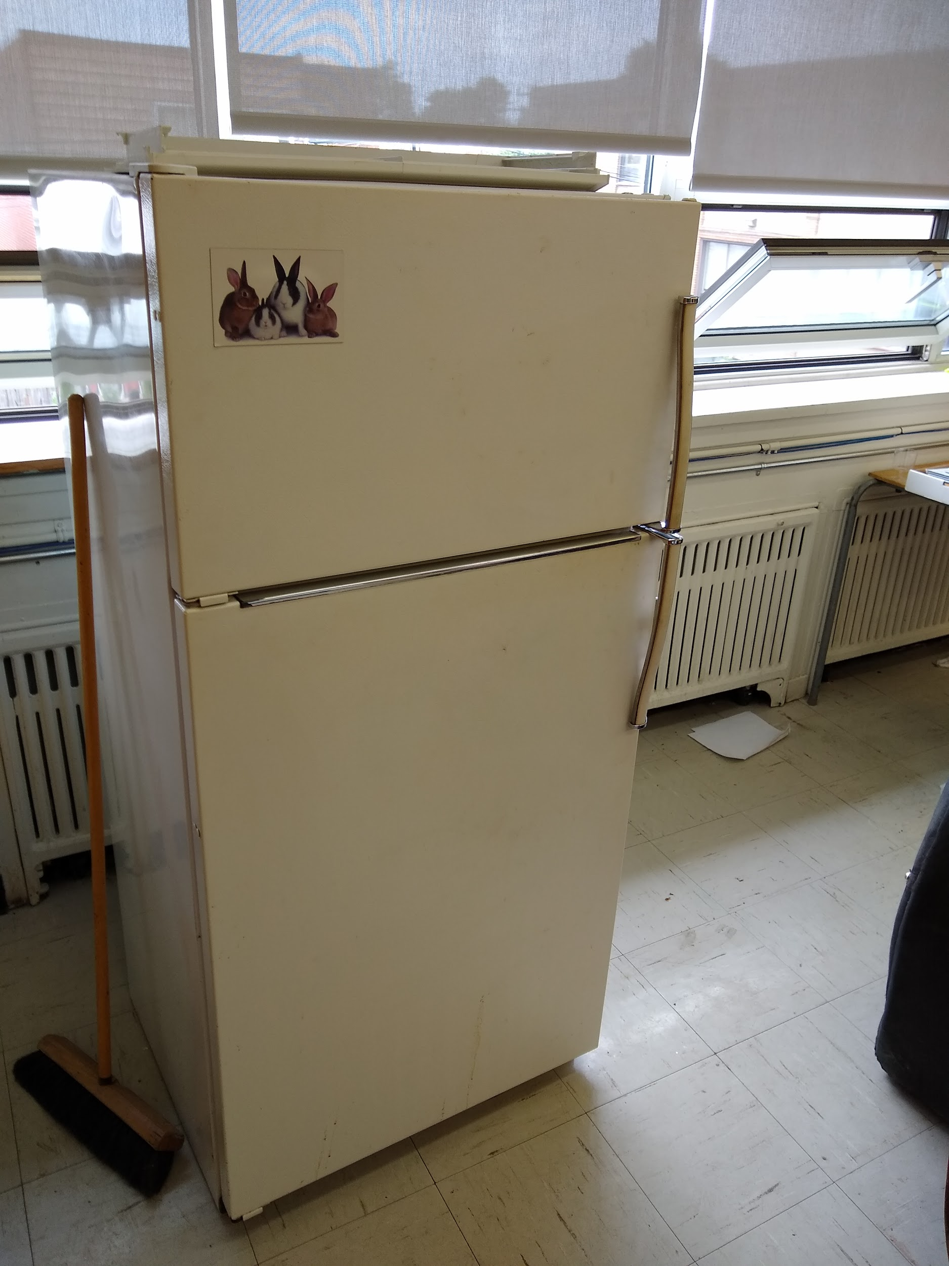 | Good | Returned to Ivan’s son
Marimba No.470 Diana 51  1951-1953 | 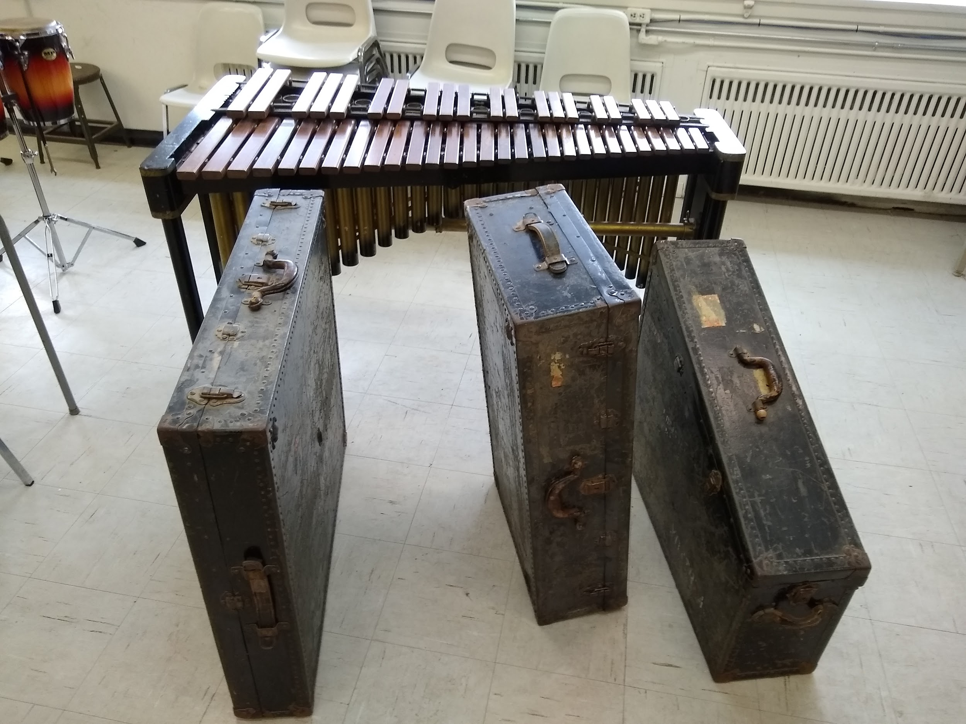  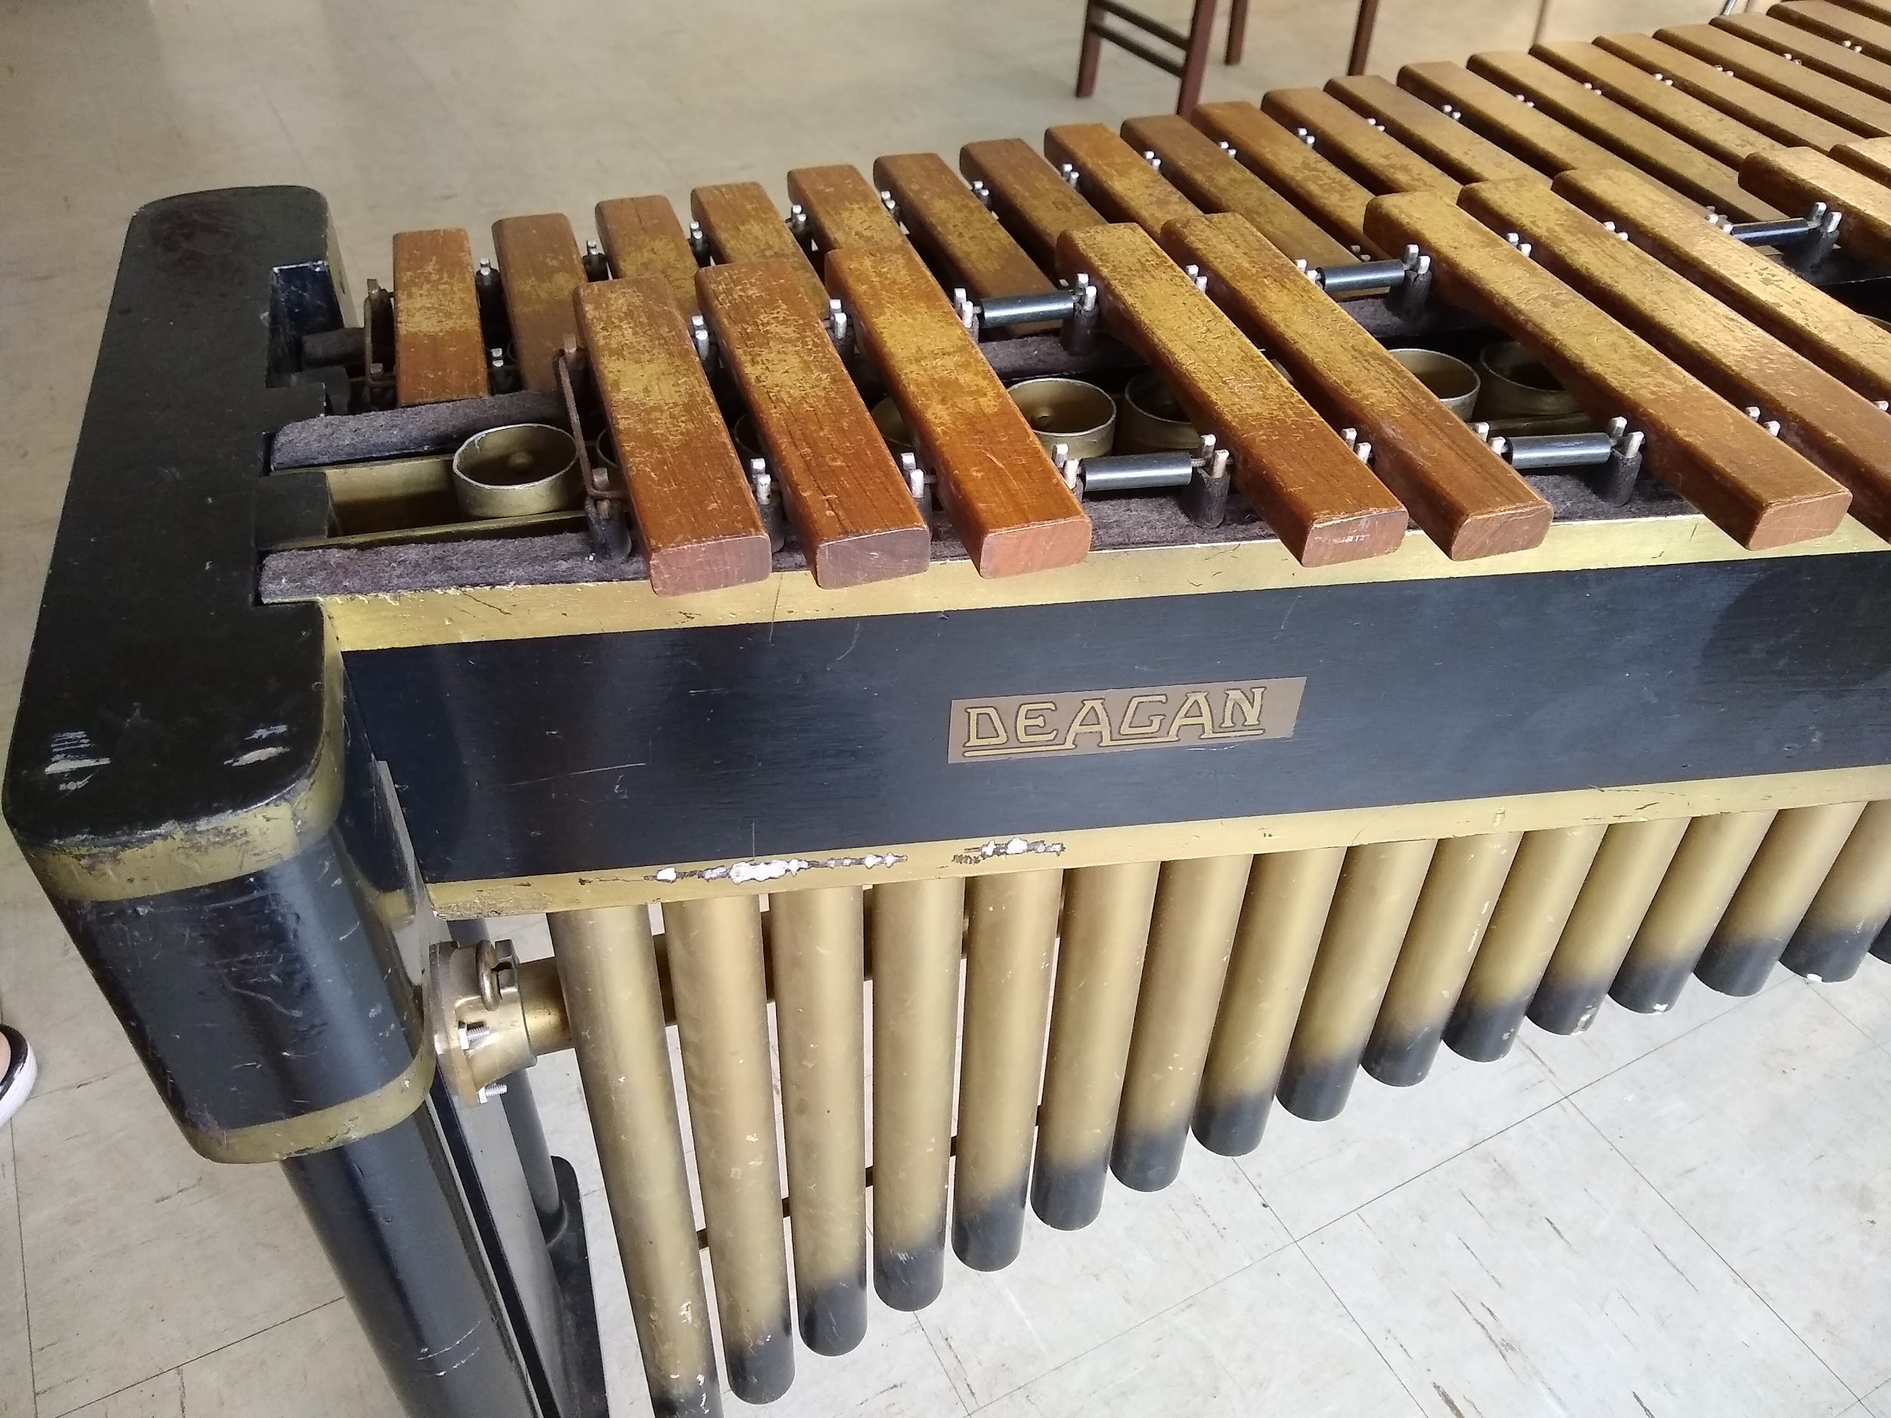  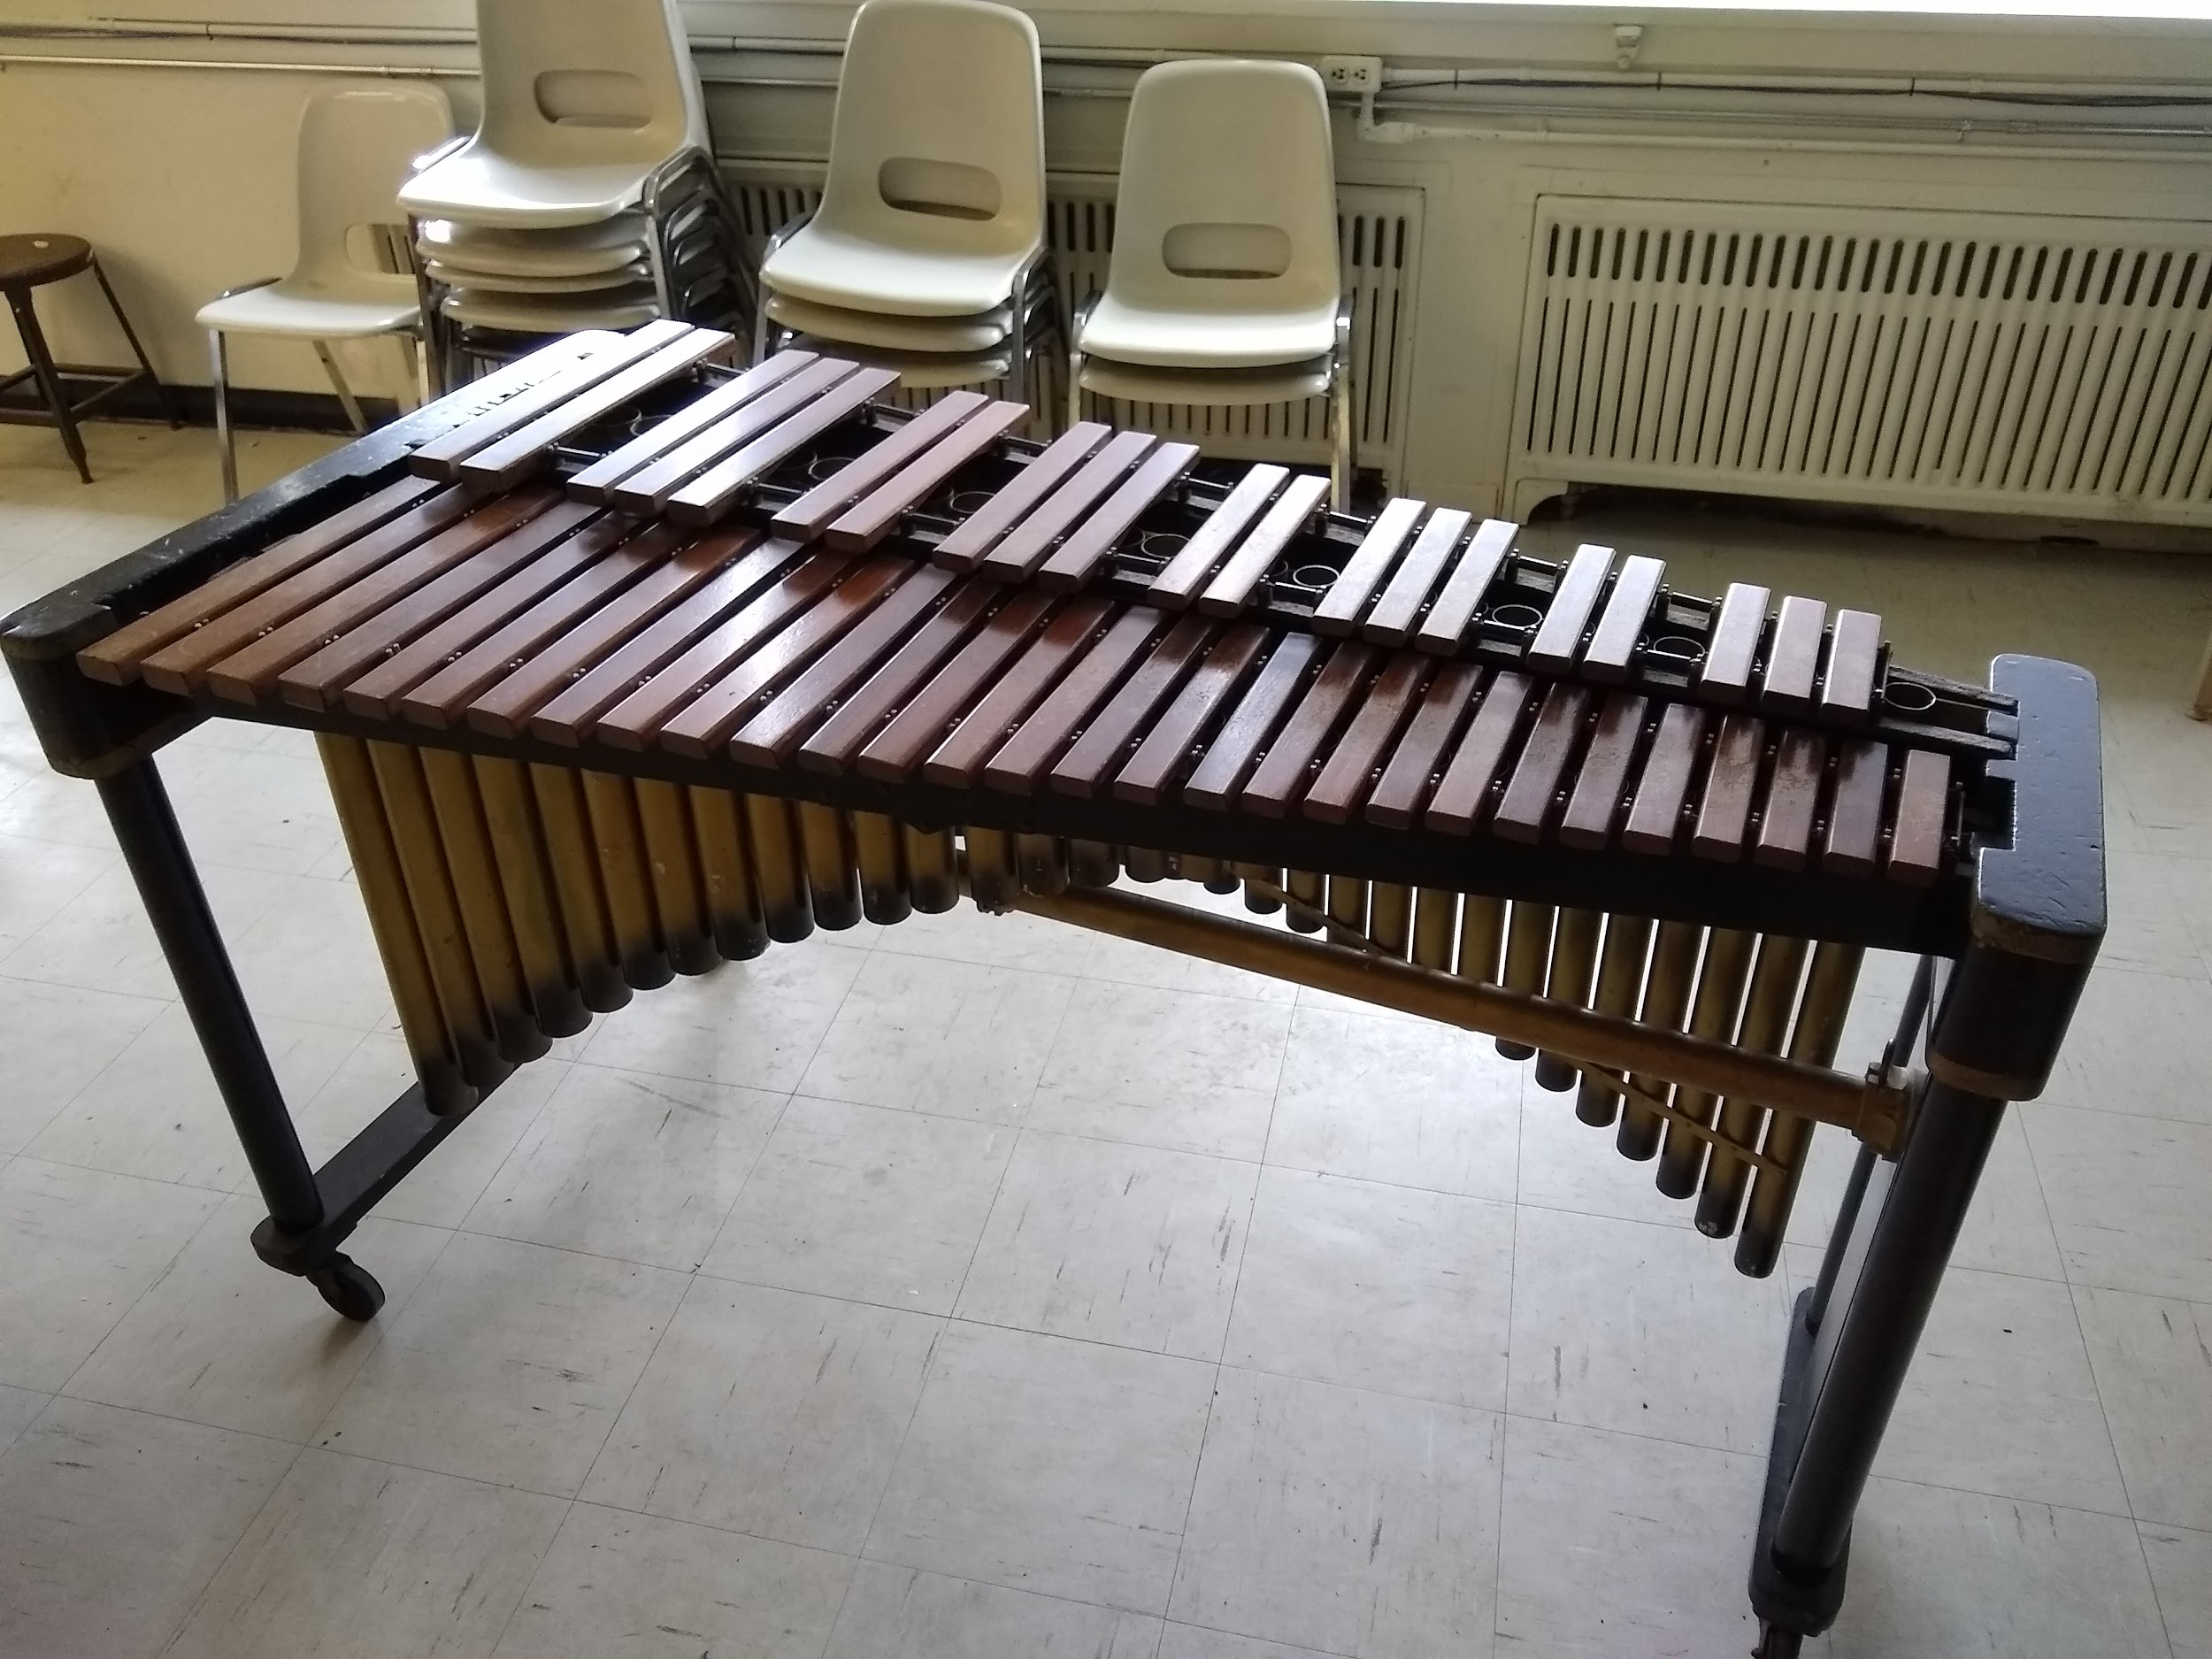 | Good | Sell  $2,800  Loaned to David Pedersen
Music Stands | 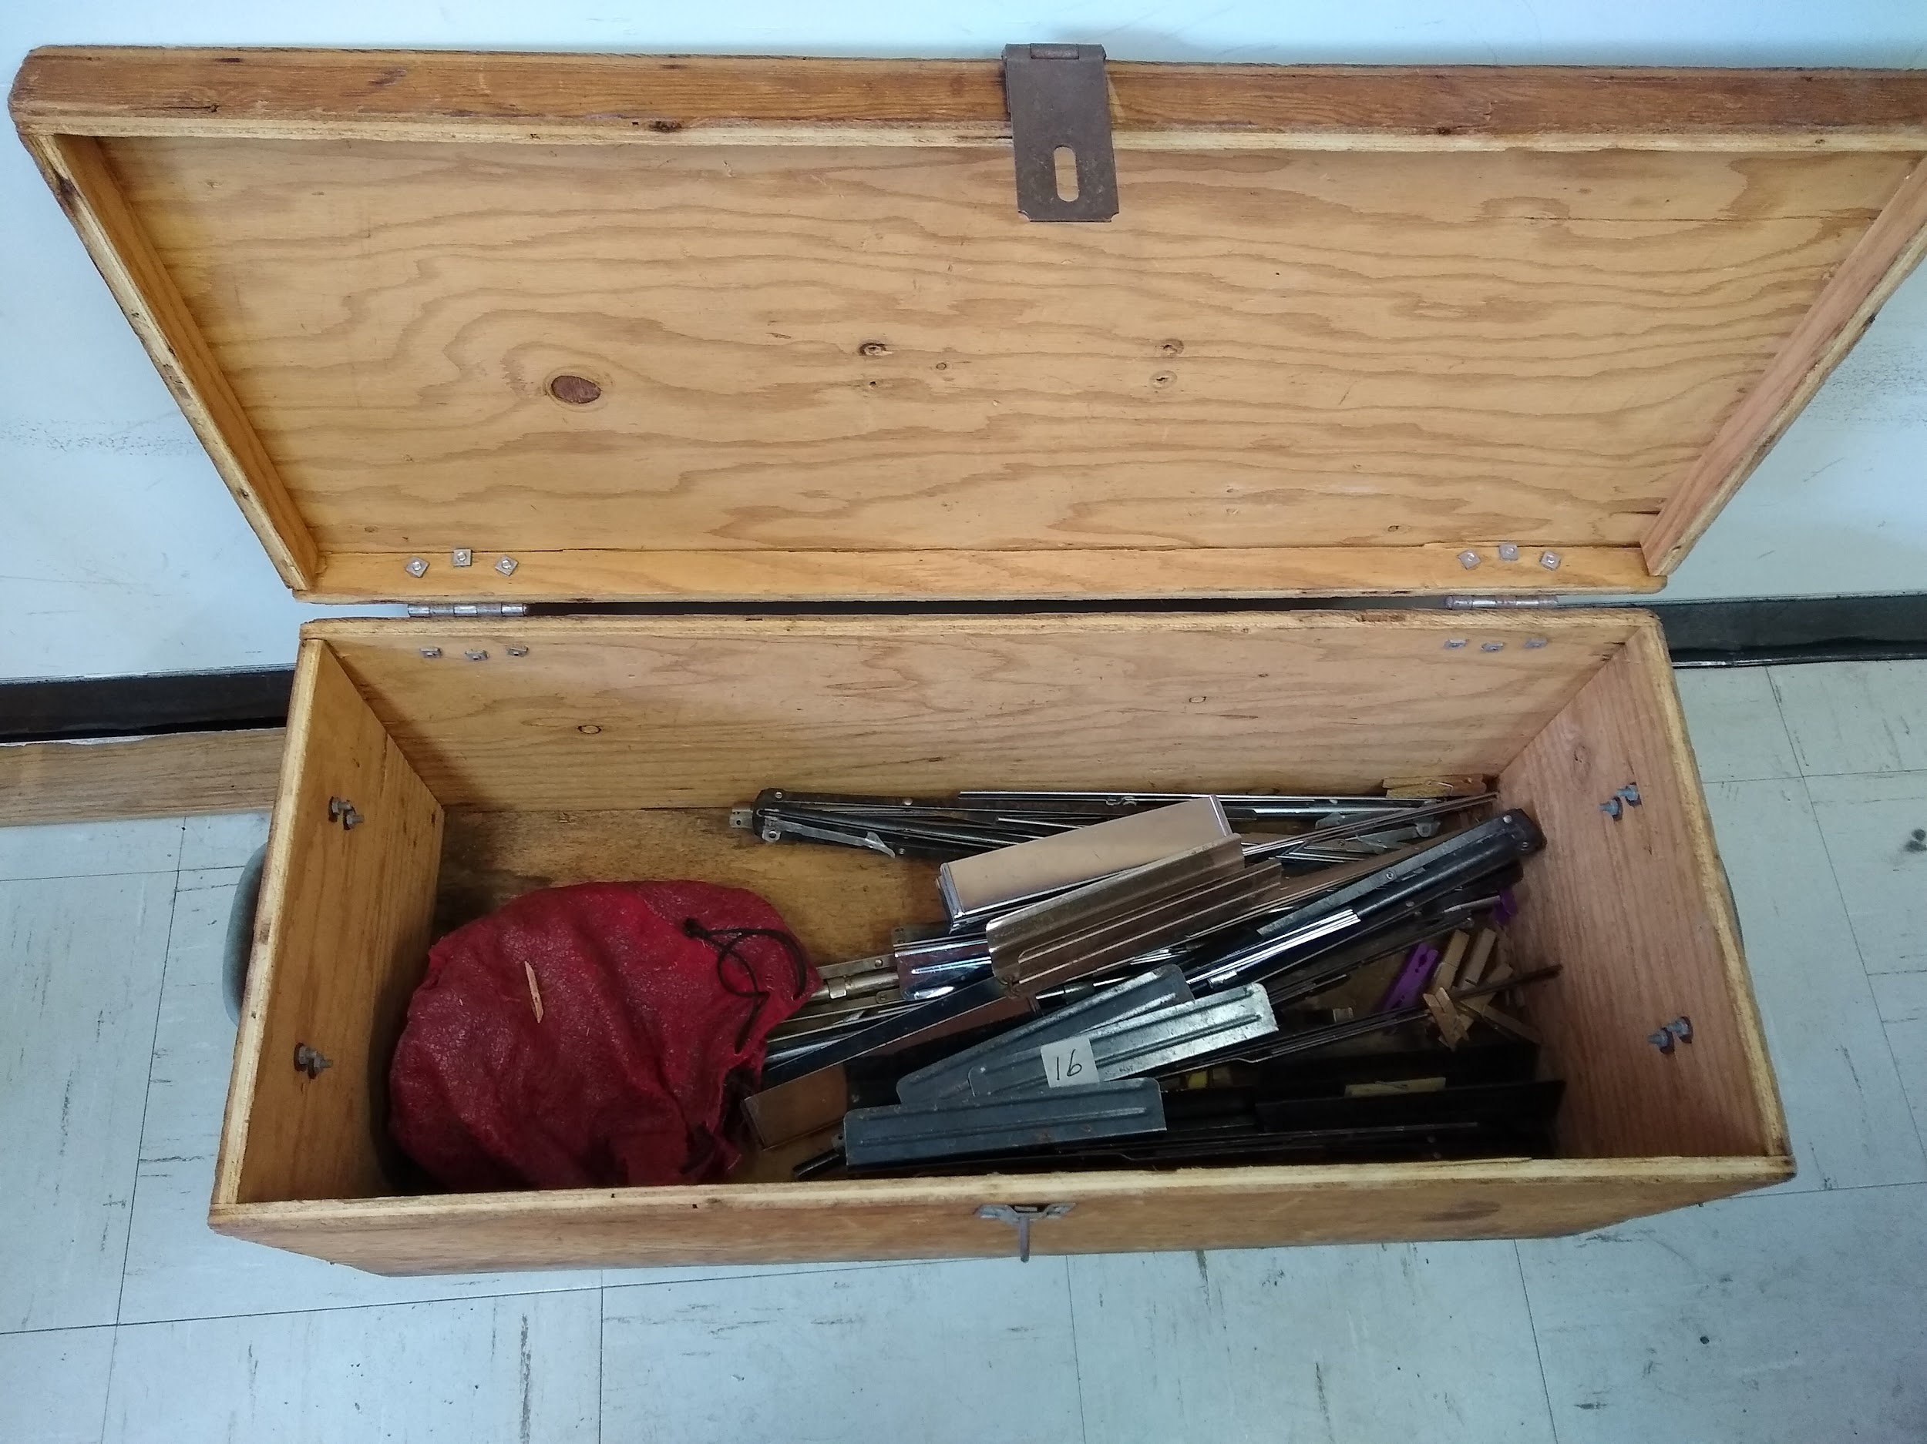 | Good | Given away Free  Susan
Mutes | 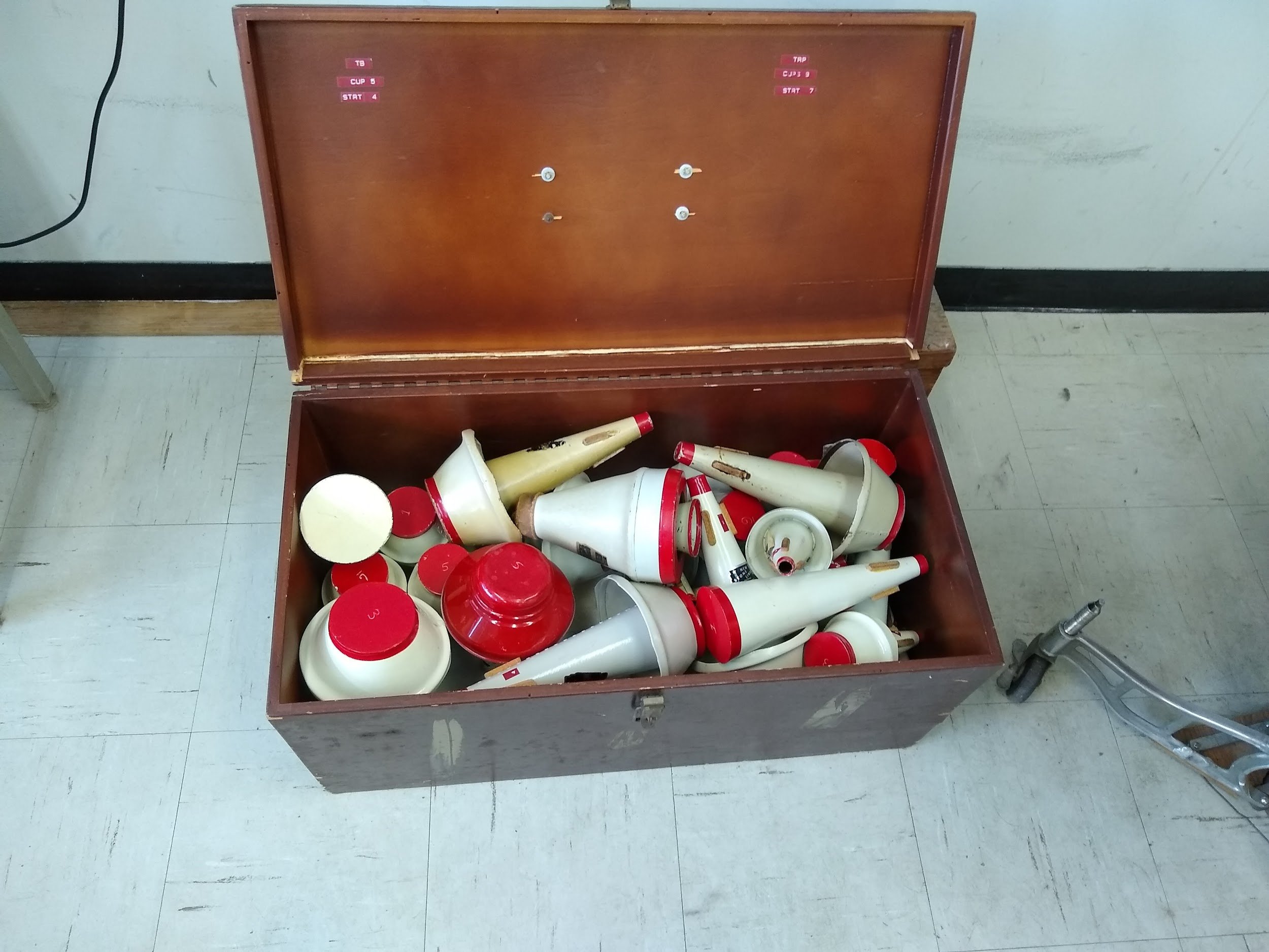 |  | Given away Free  Susan  Alain  Elizabeth  Micheline  Kieran
Photocopier | 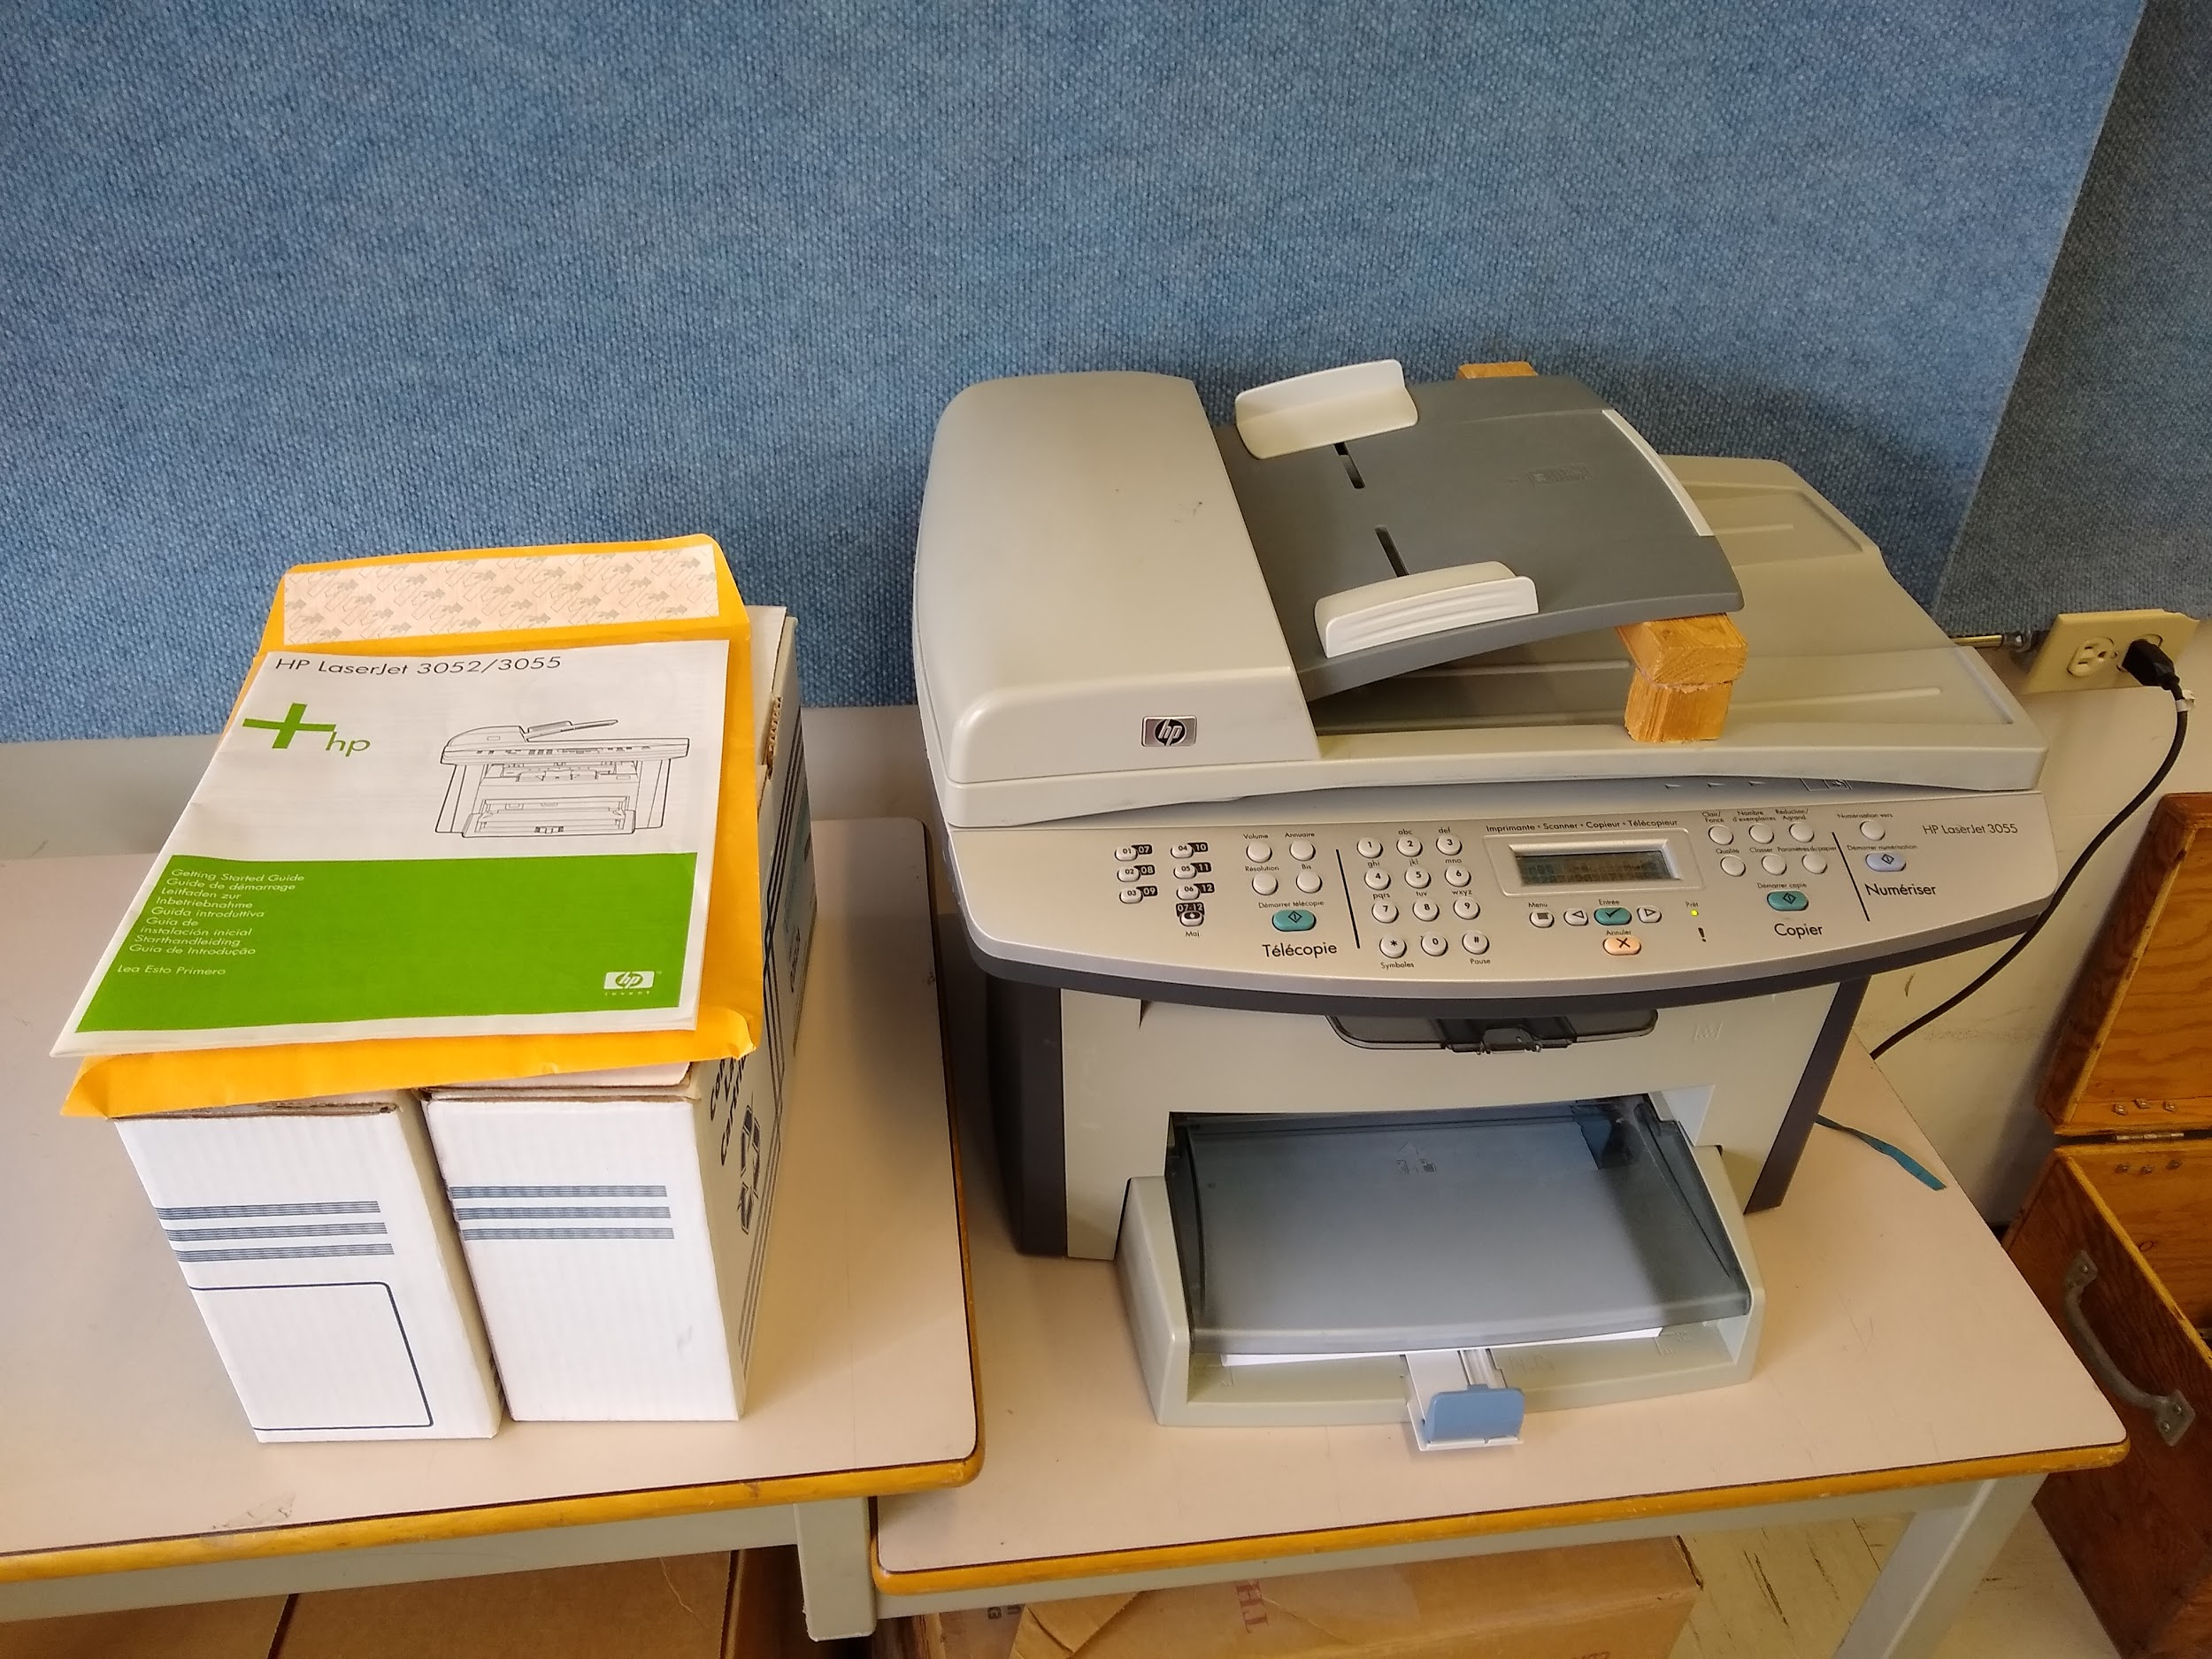 | Good | Returned to Guy
Sound Proofing | 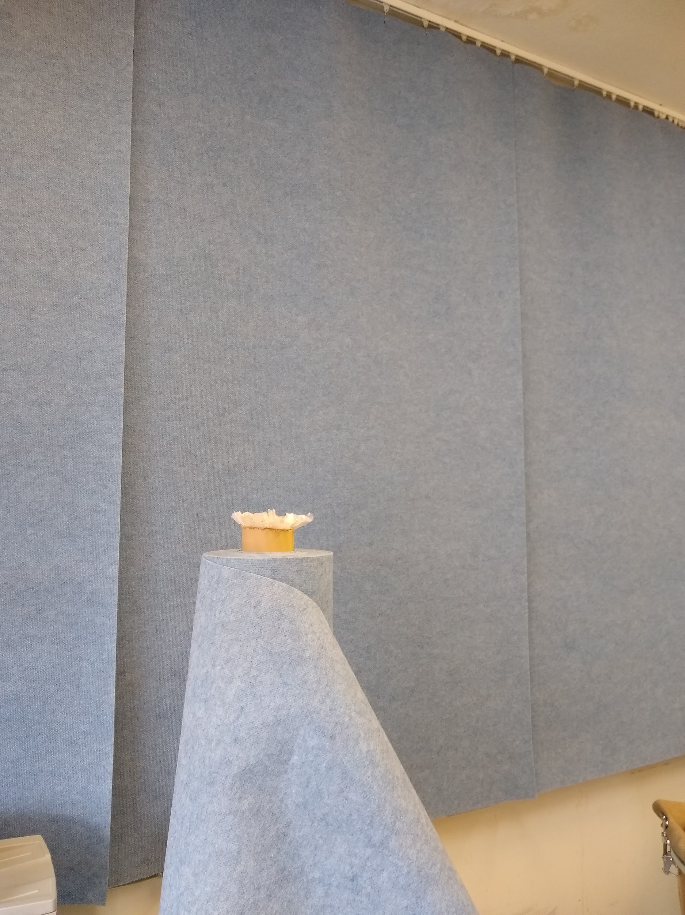 | Good | Stored at Claire’s
Sousaphone | 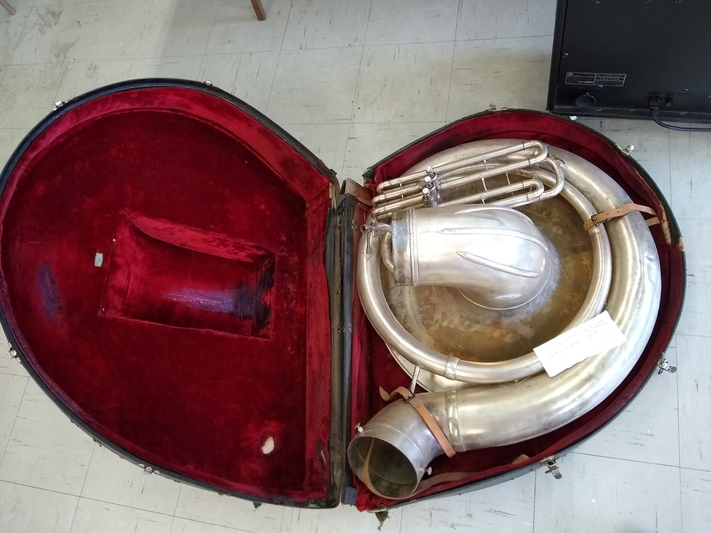 | Good | Loaned to Victoria McHugh
Realistic Vintage 70's PA-99 Columns 160 Watts 8 Ohm Utah 10" Speakers 1970's | 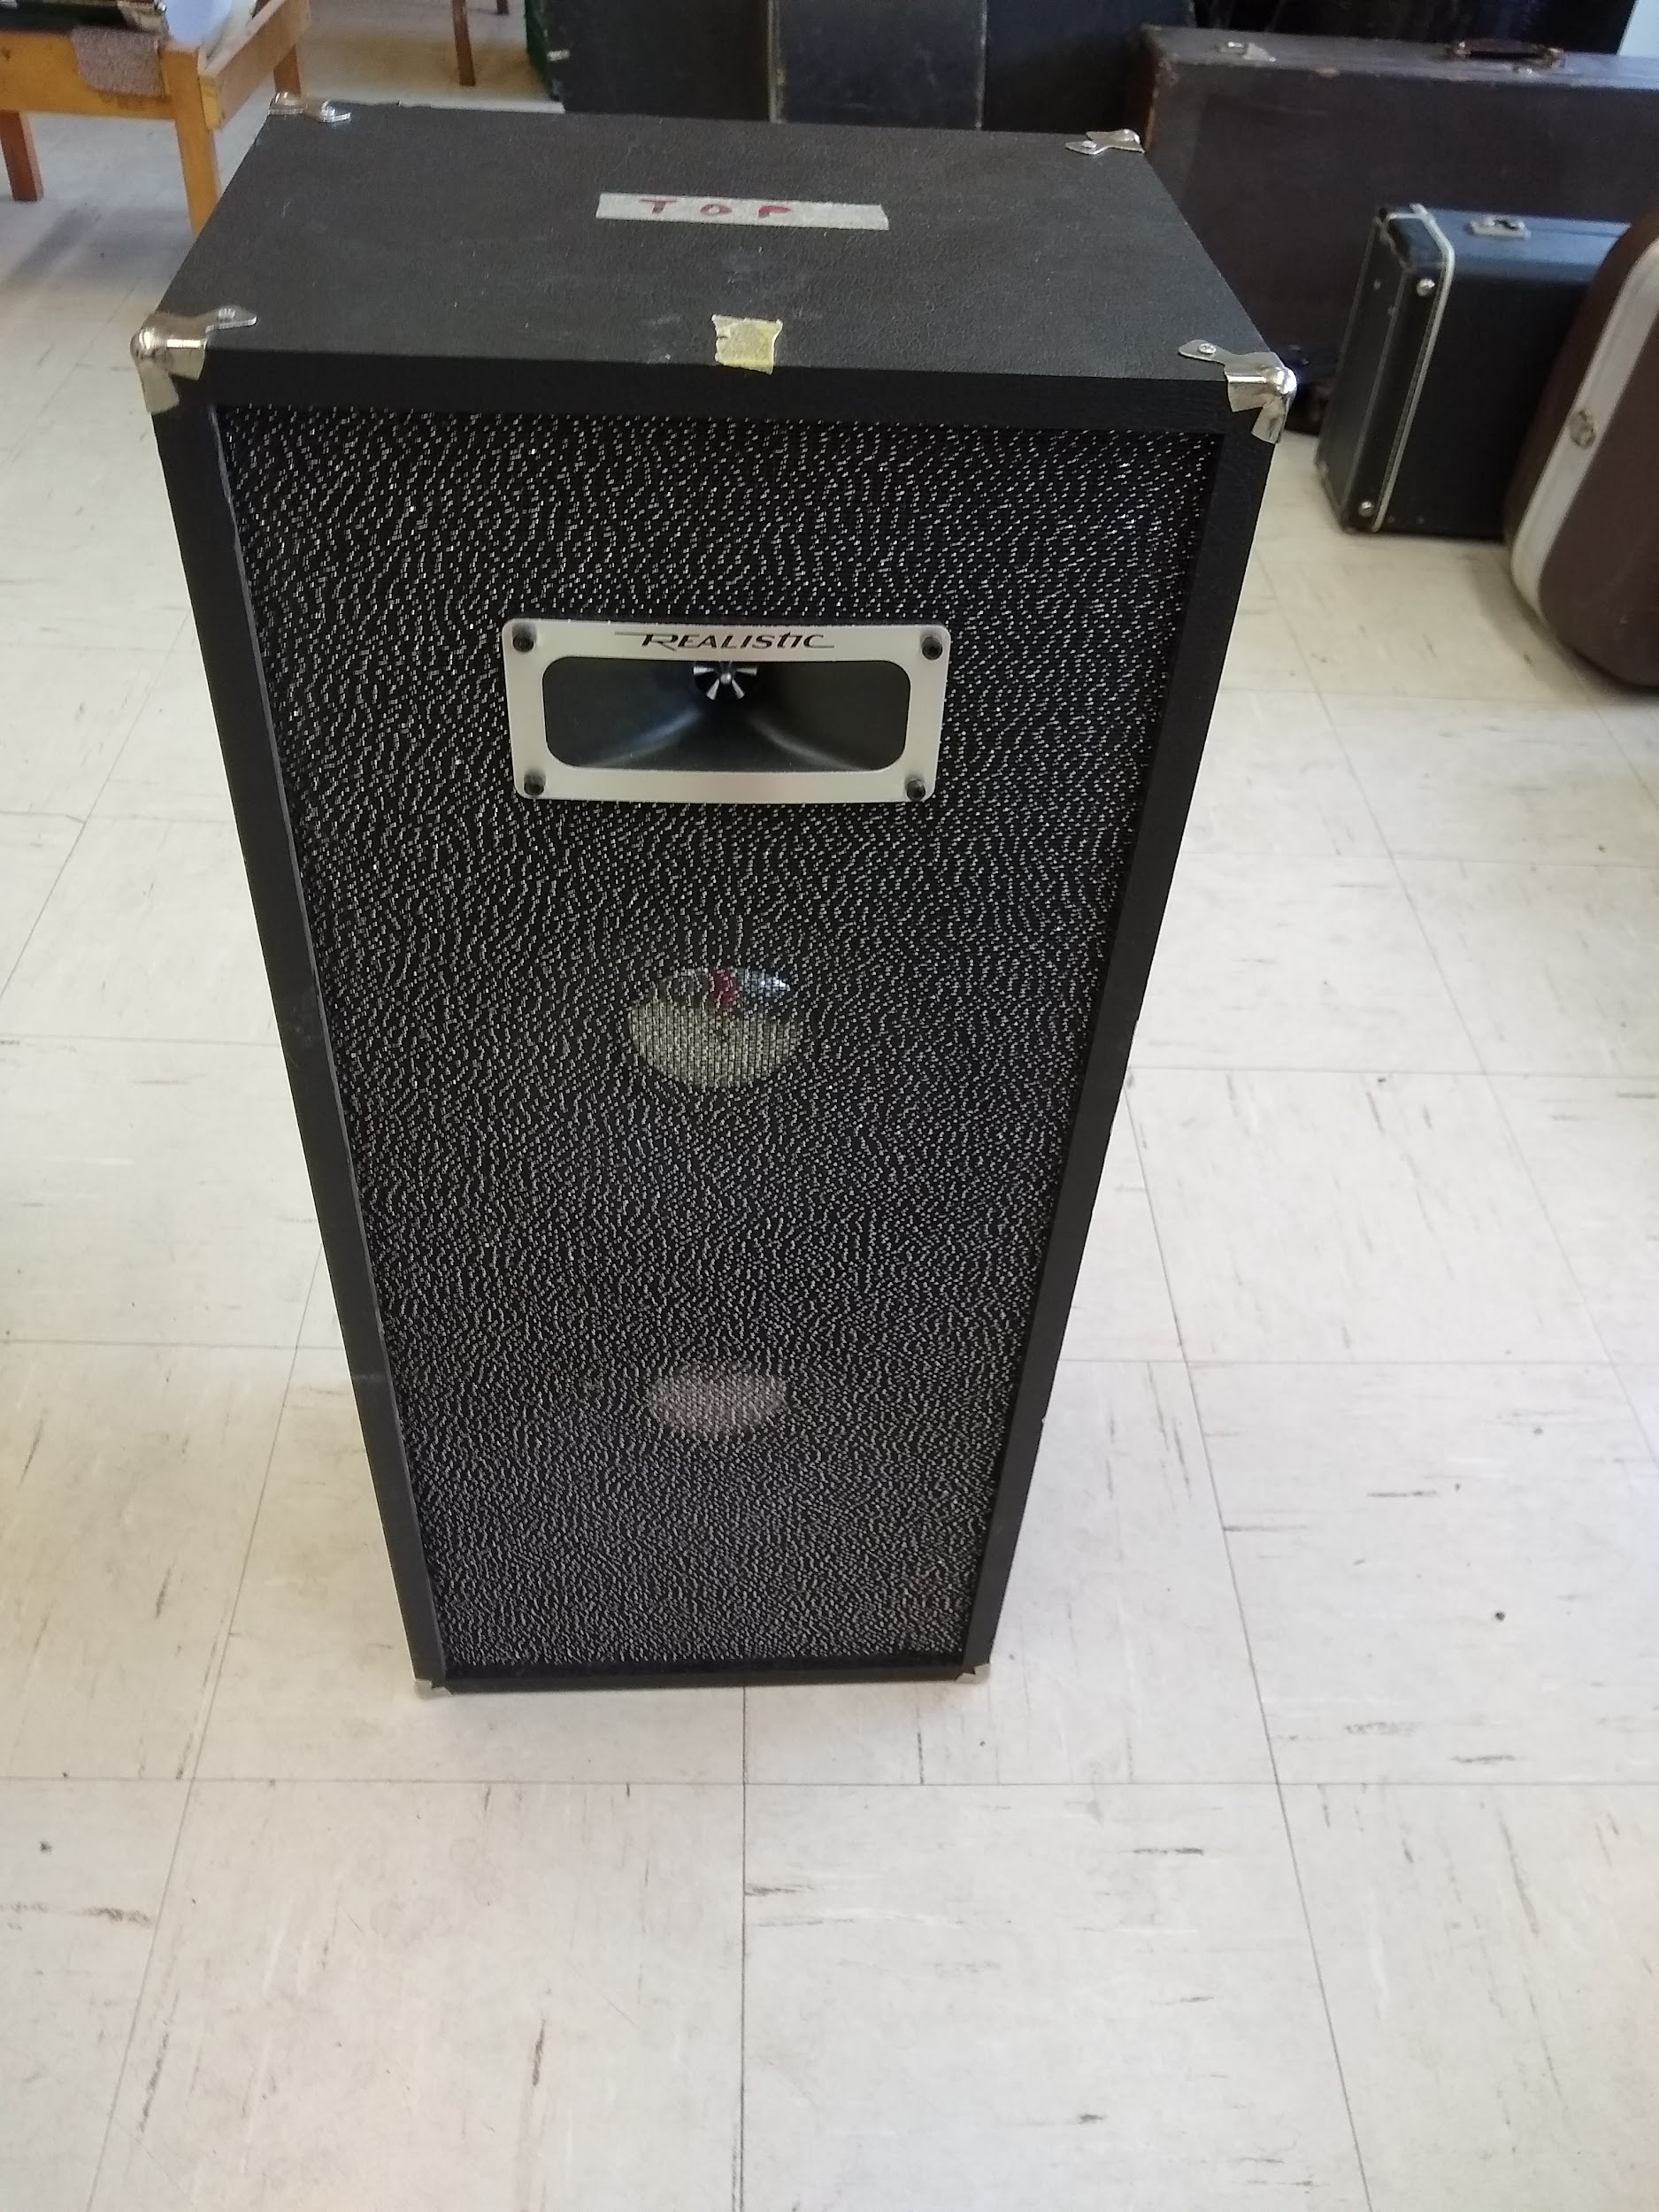  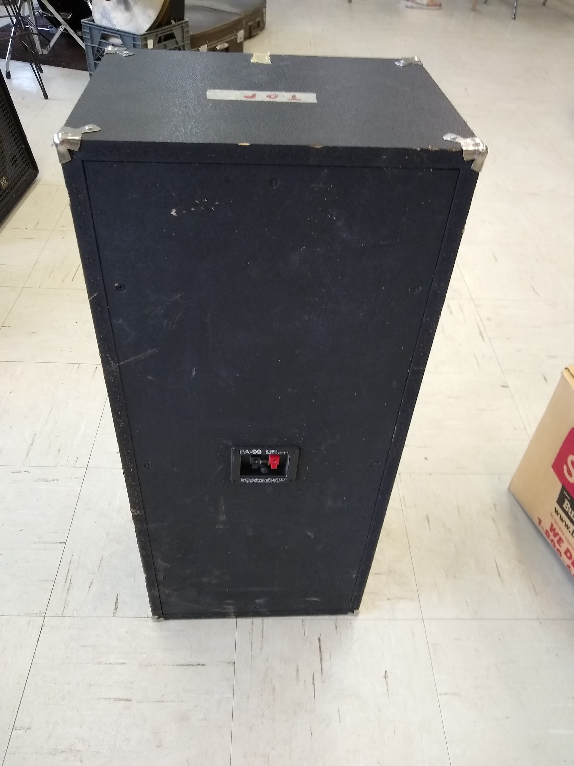 | Good | Discarded
Tenor Sax | 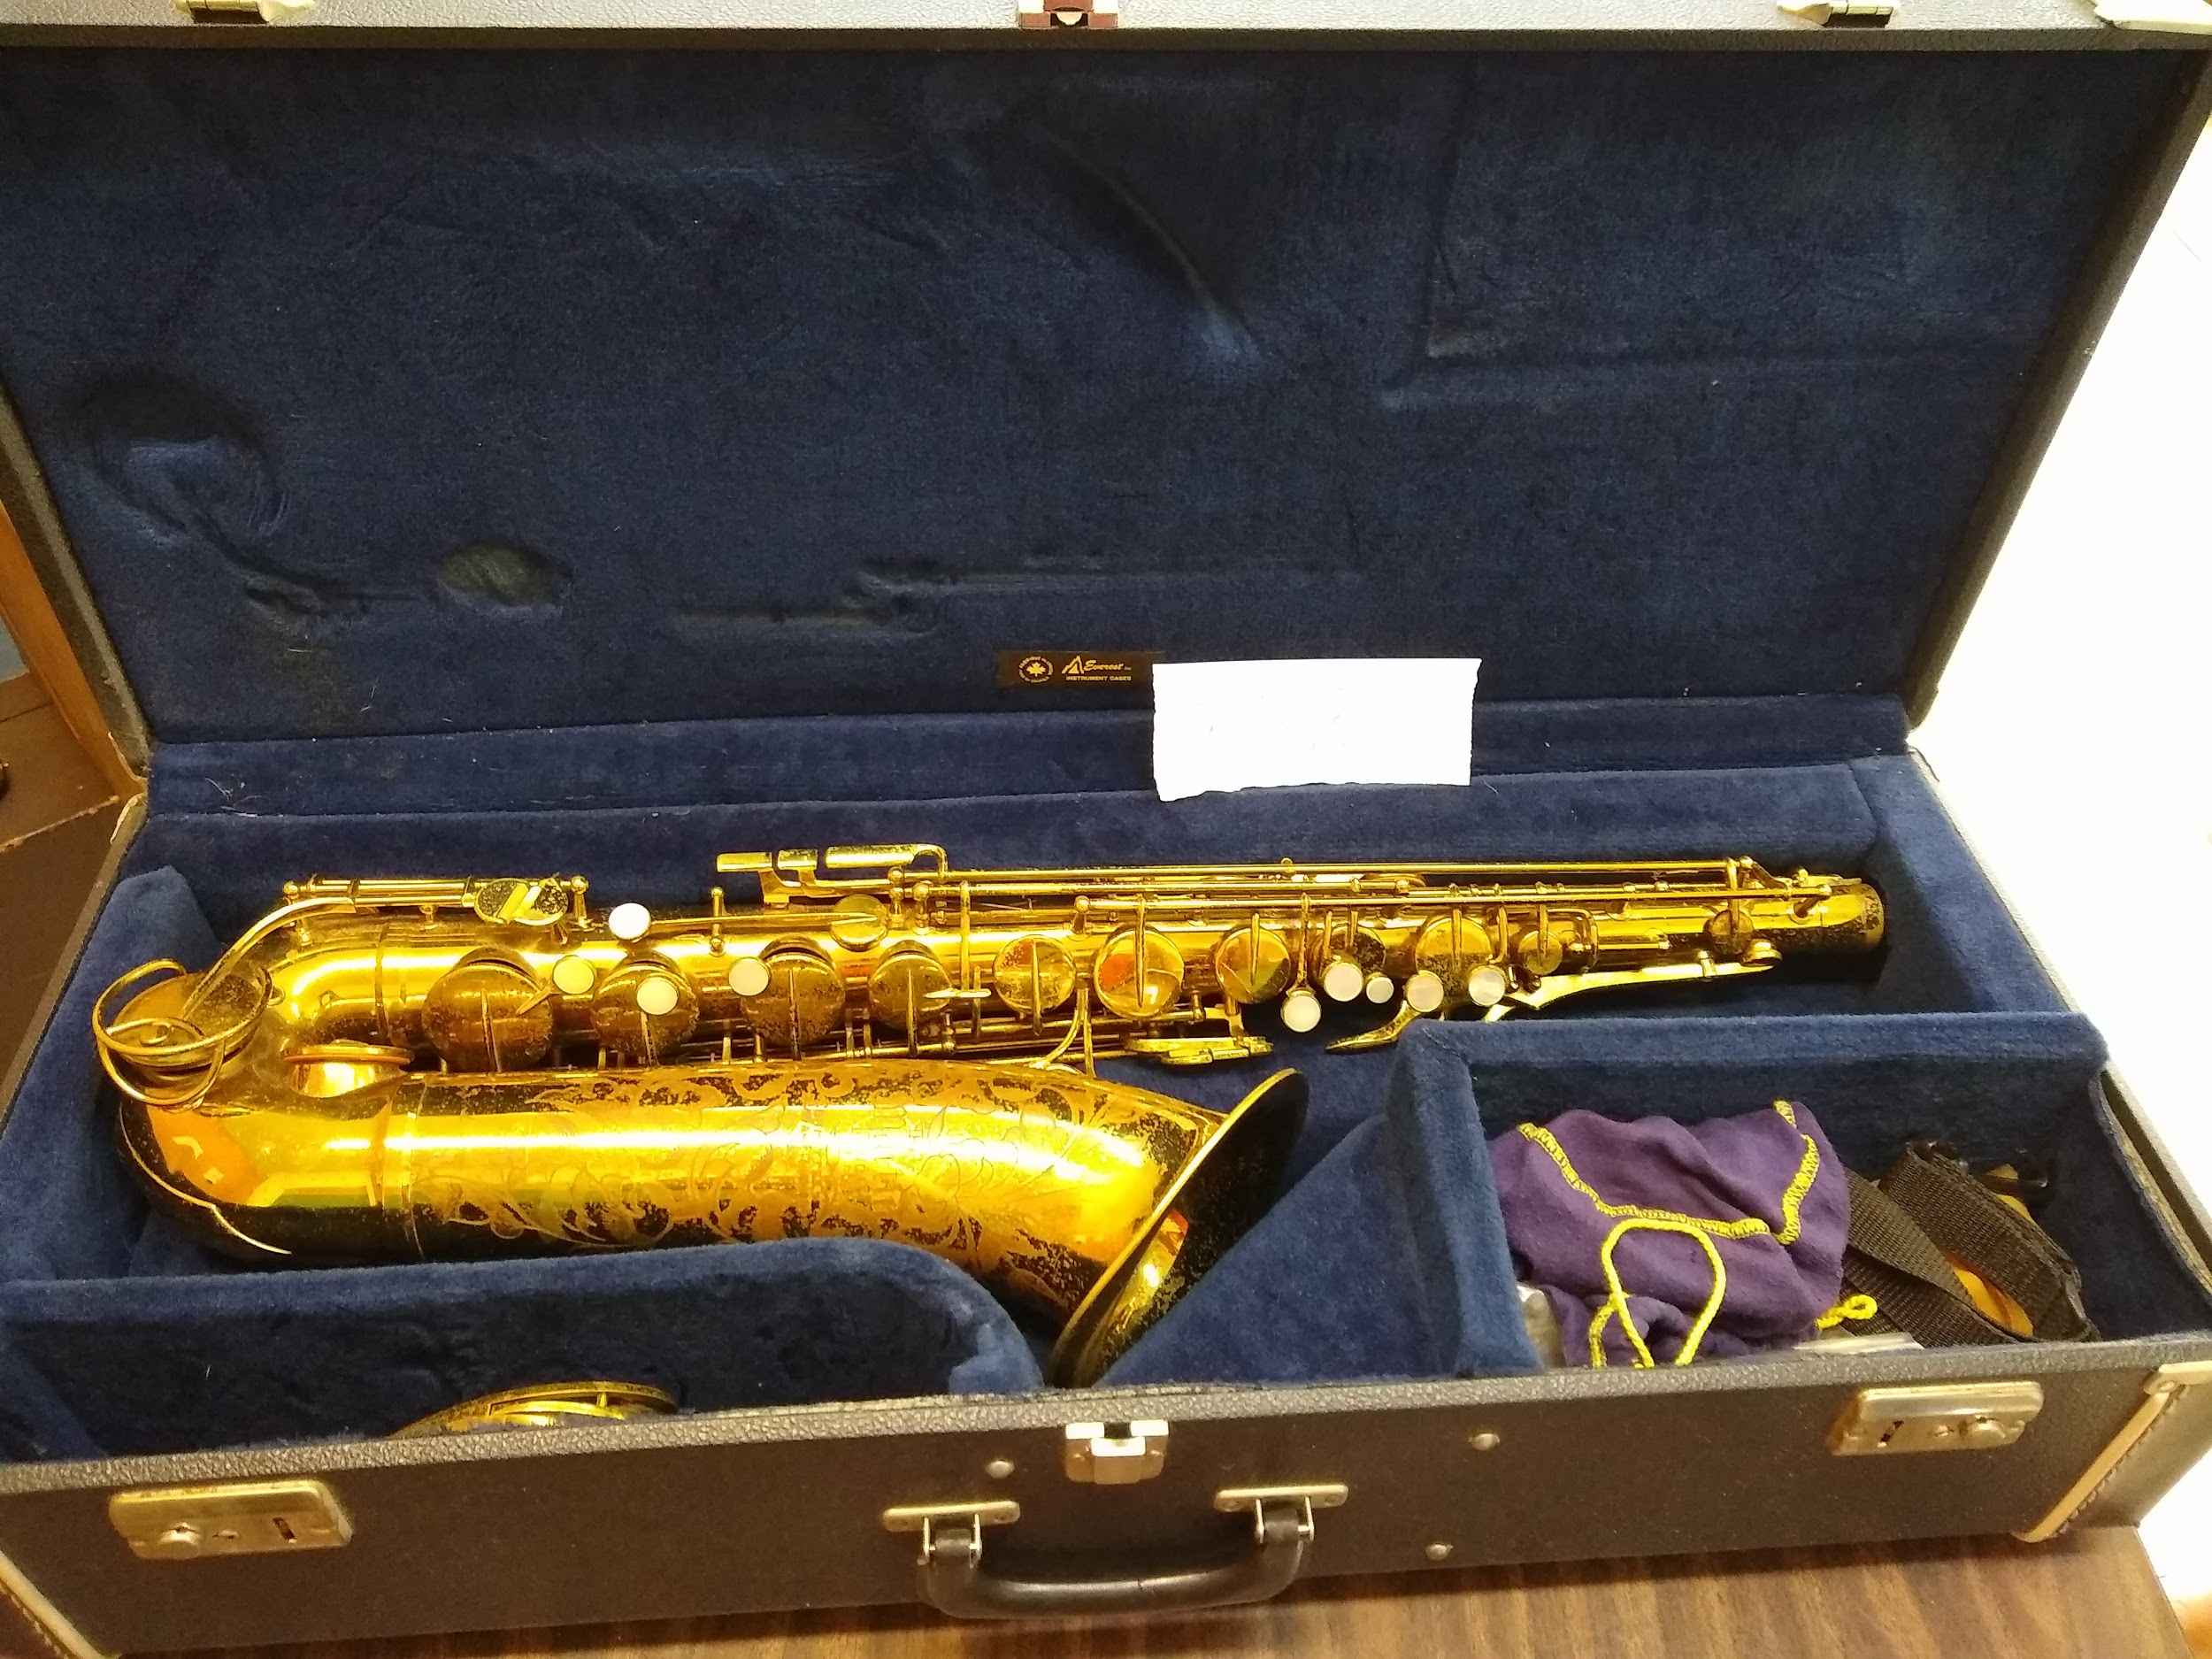 | Needs repair | Sold  $50  Claire
Timpani | 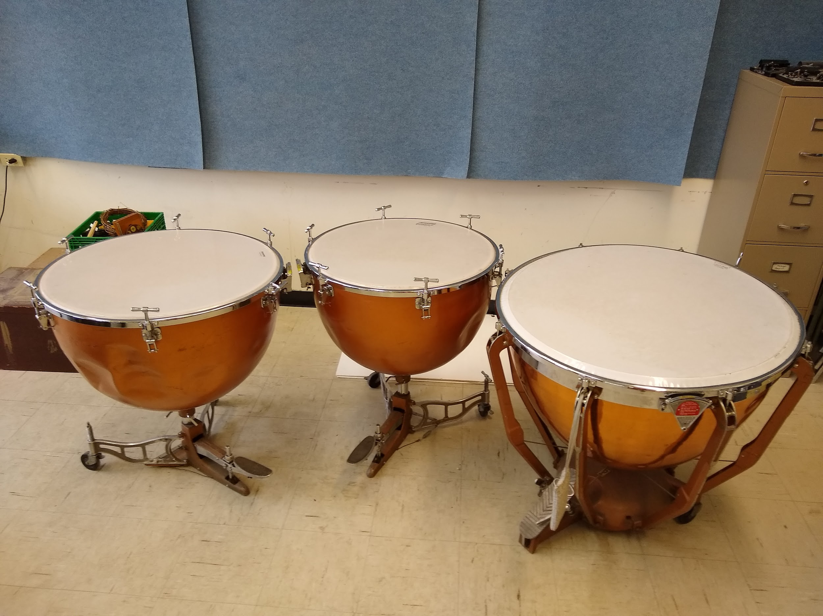  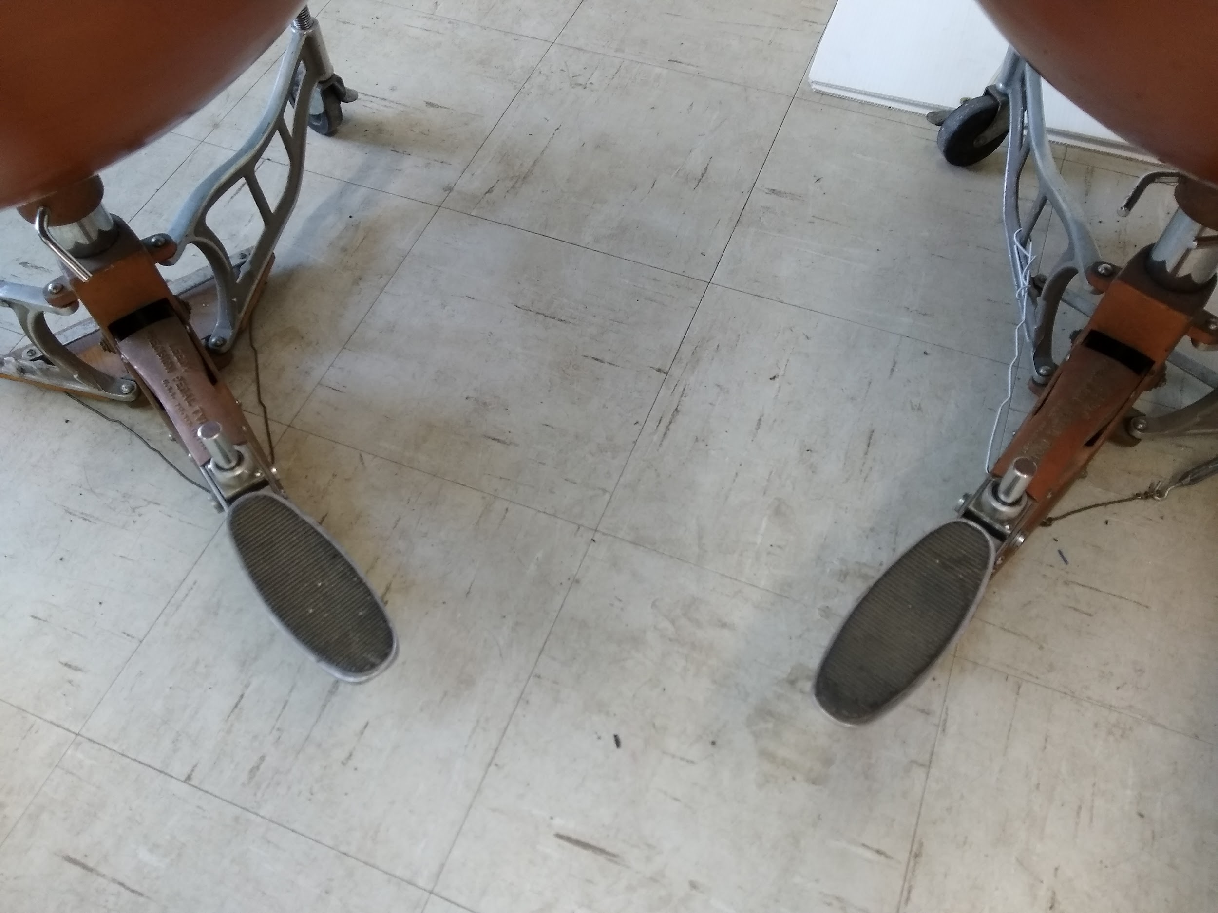  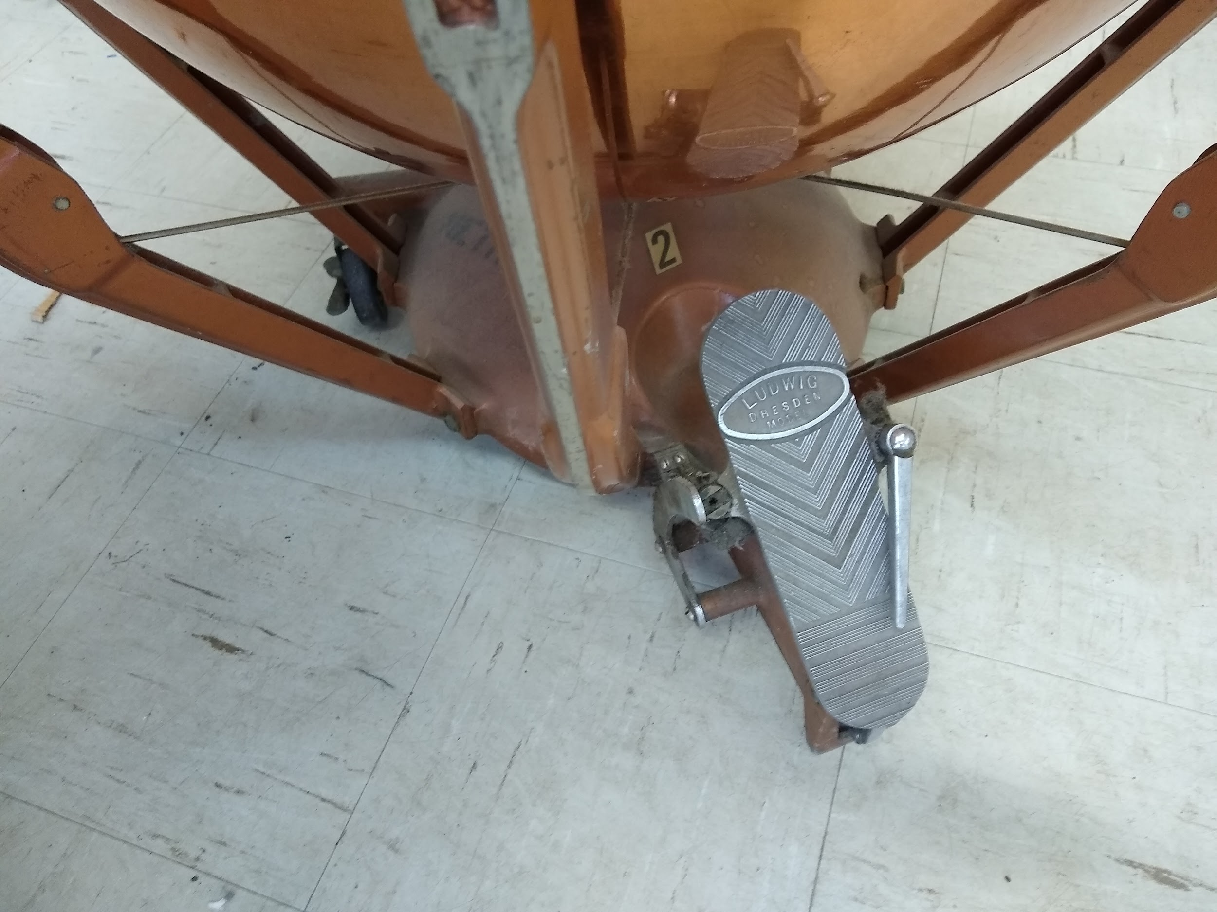 | Good | LCB - Stored at the Entrepot
Trombone 1 F.E. Olds | 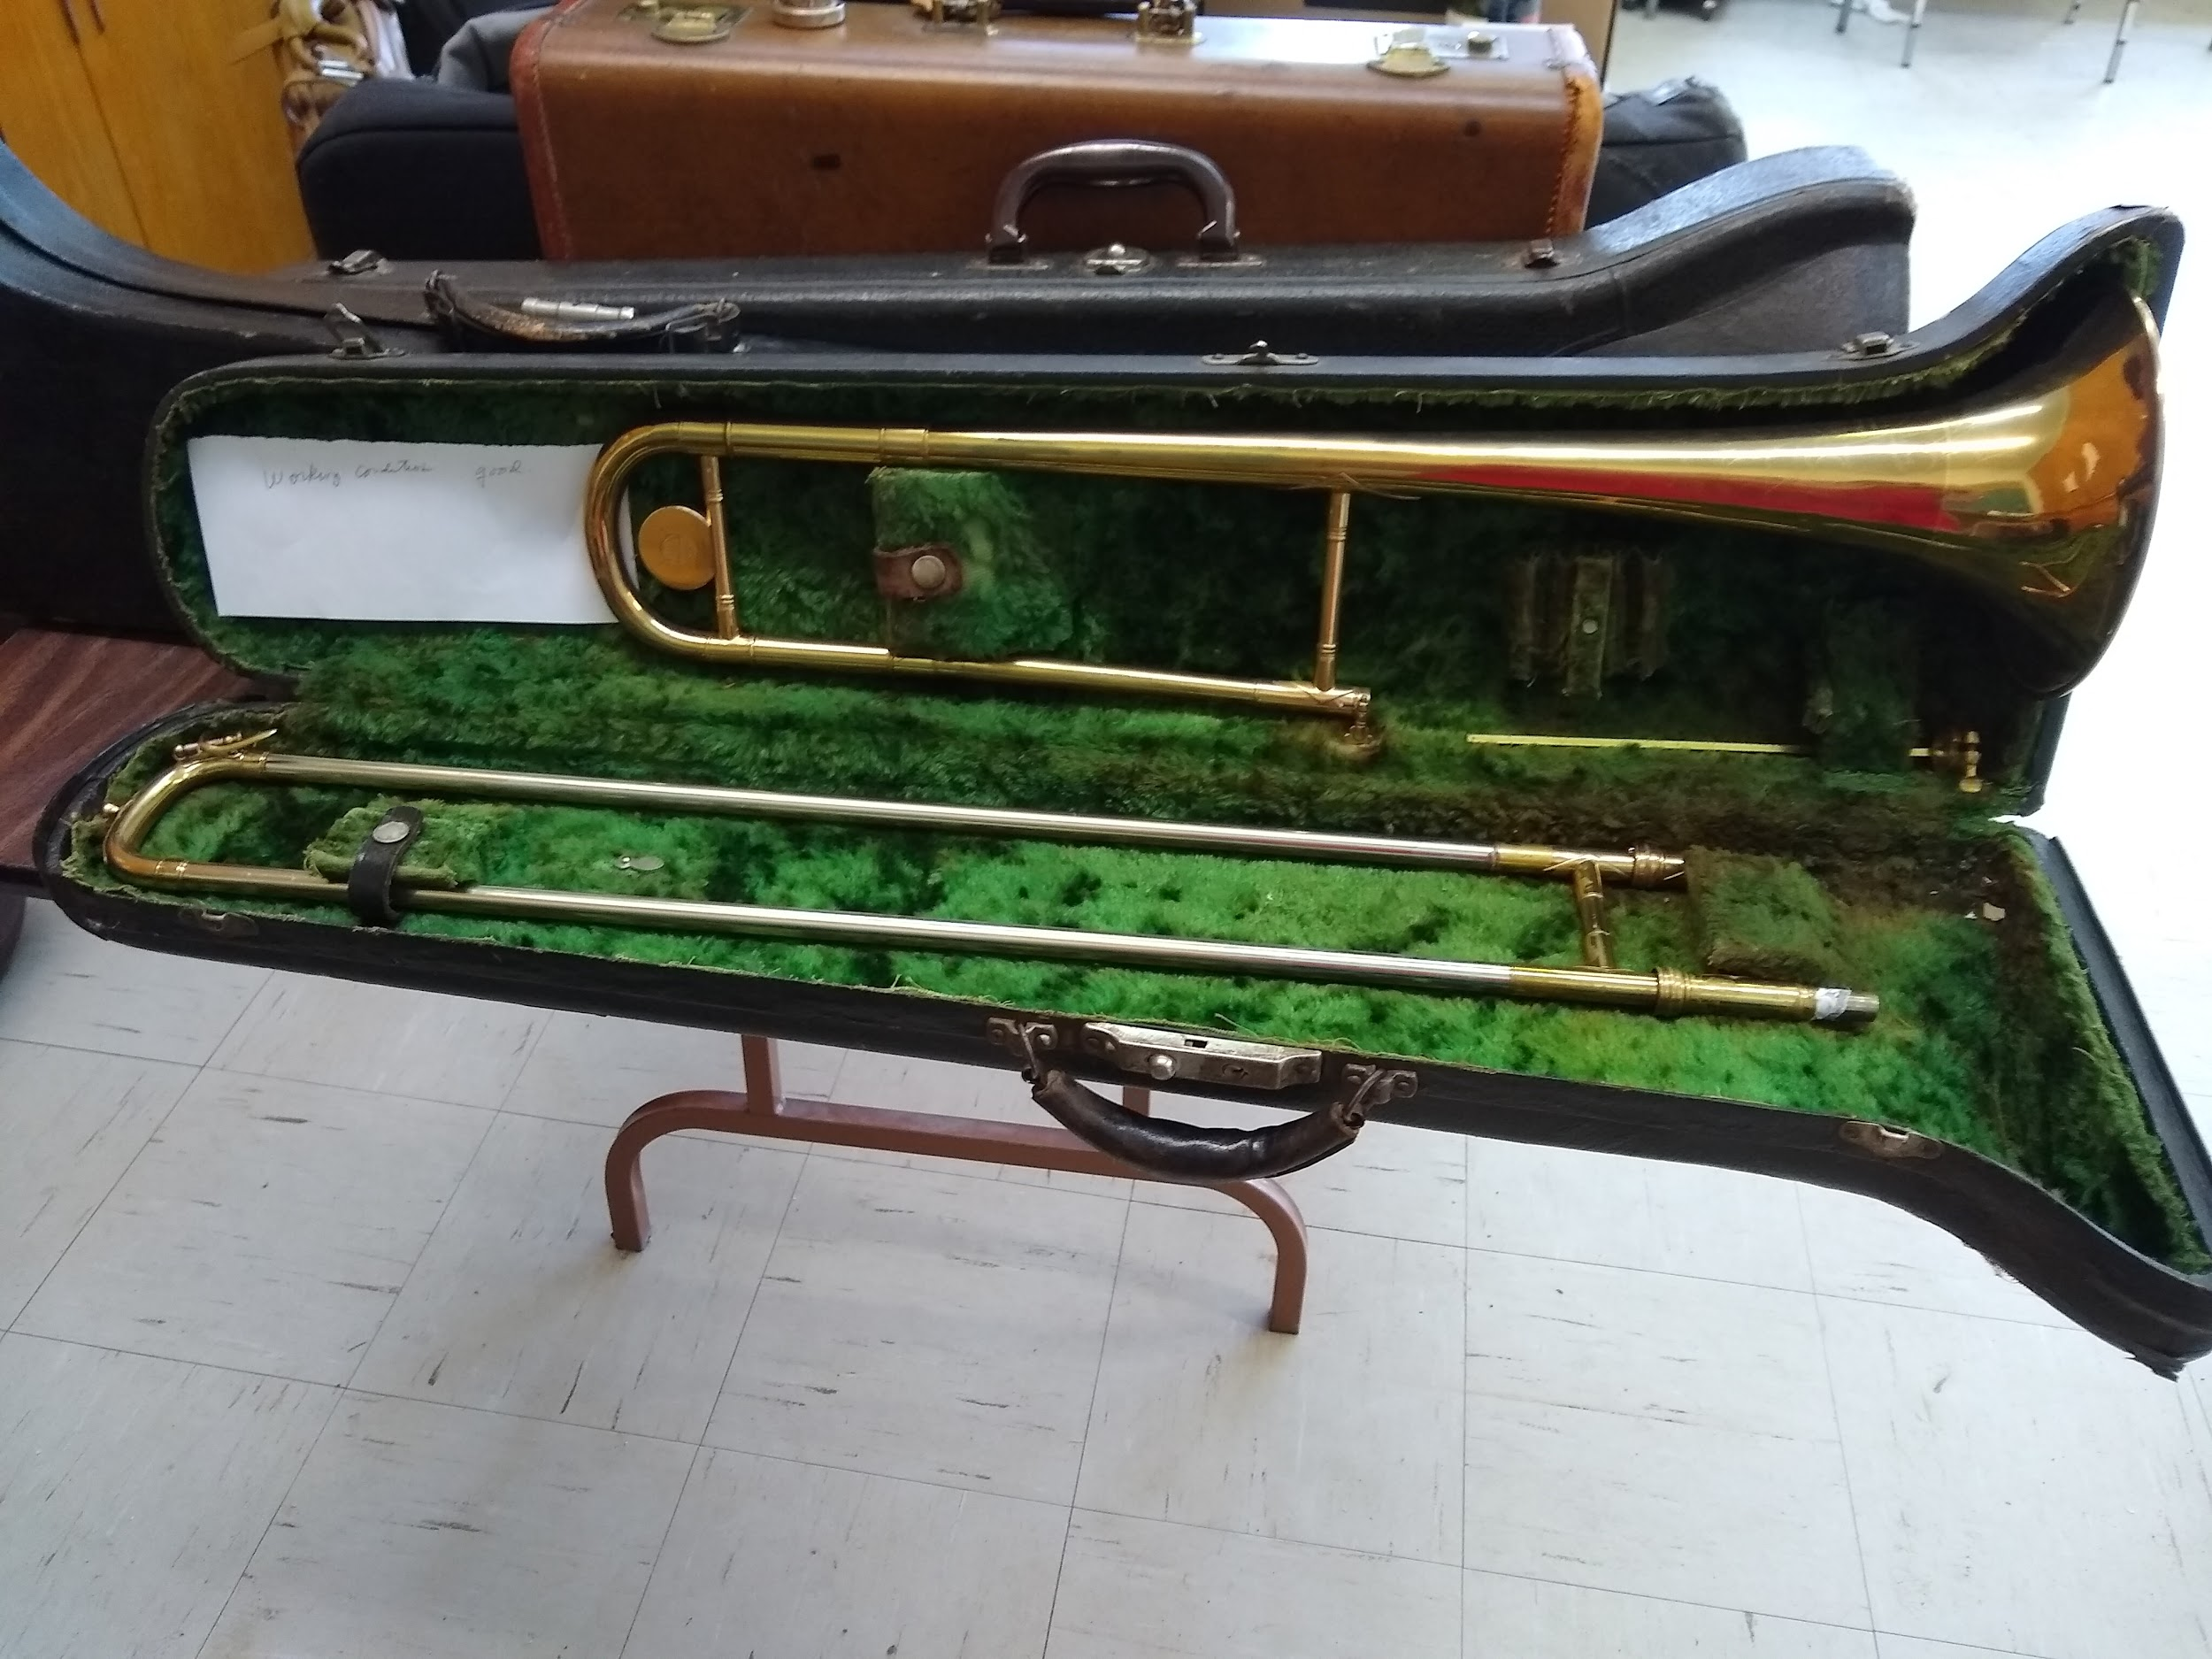 | Good | Sold  $50  Elizabeth Huyer
Trombone 2 F.E. Olds | 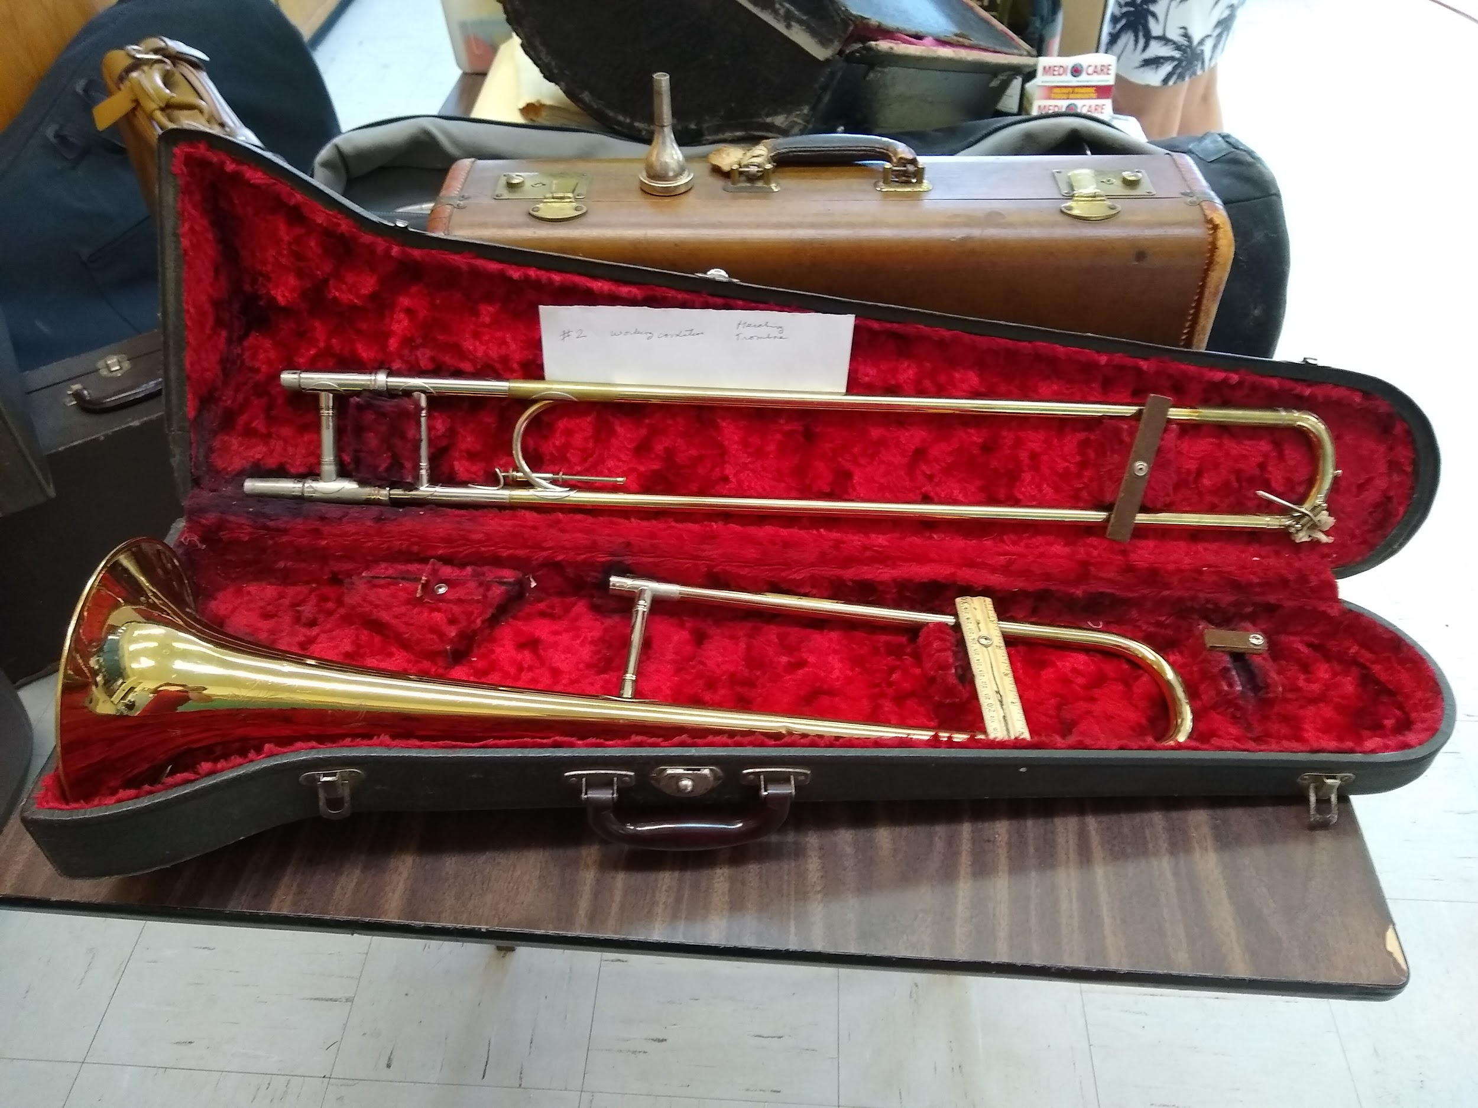 | Needs repair and one rail is half length | Sold  $20  Elizabeth Huyer
Trombone 3 Imperial | 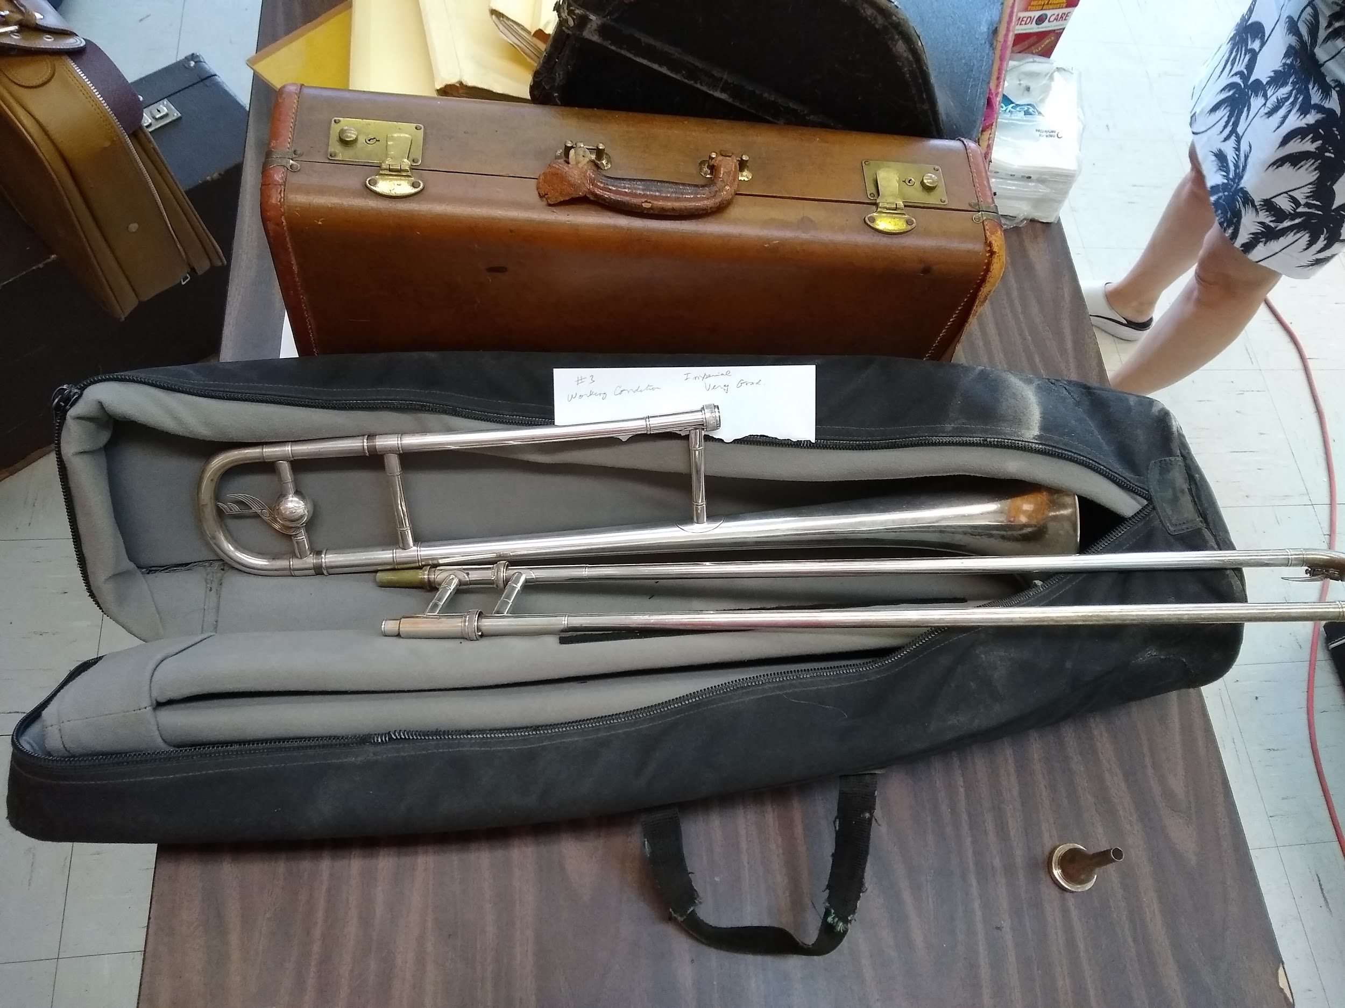 | Good | Sold  $200  Micheline Plante
Trombone 4 |  | Good | Stored at Ivan’s
Trumpet Imperial MArk VI | 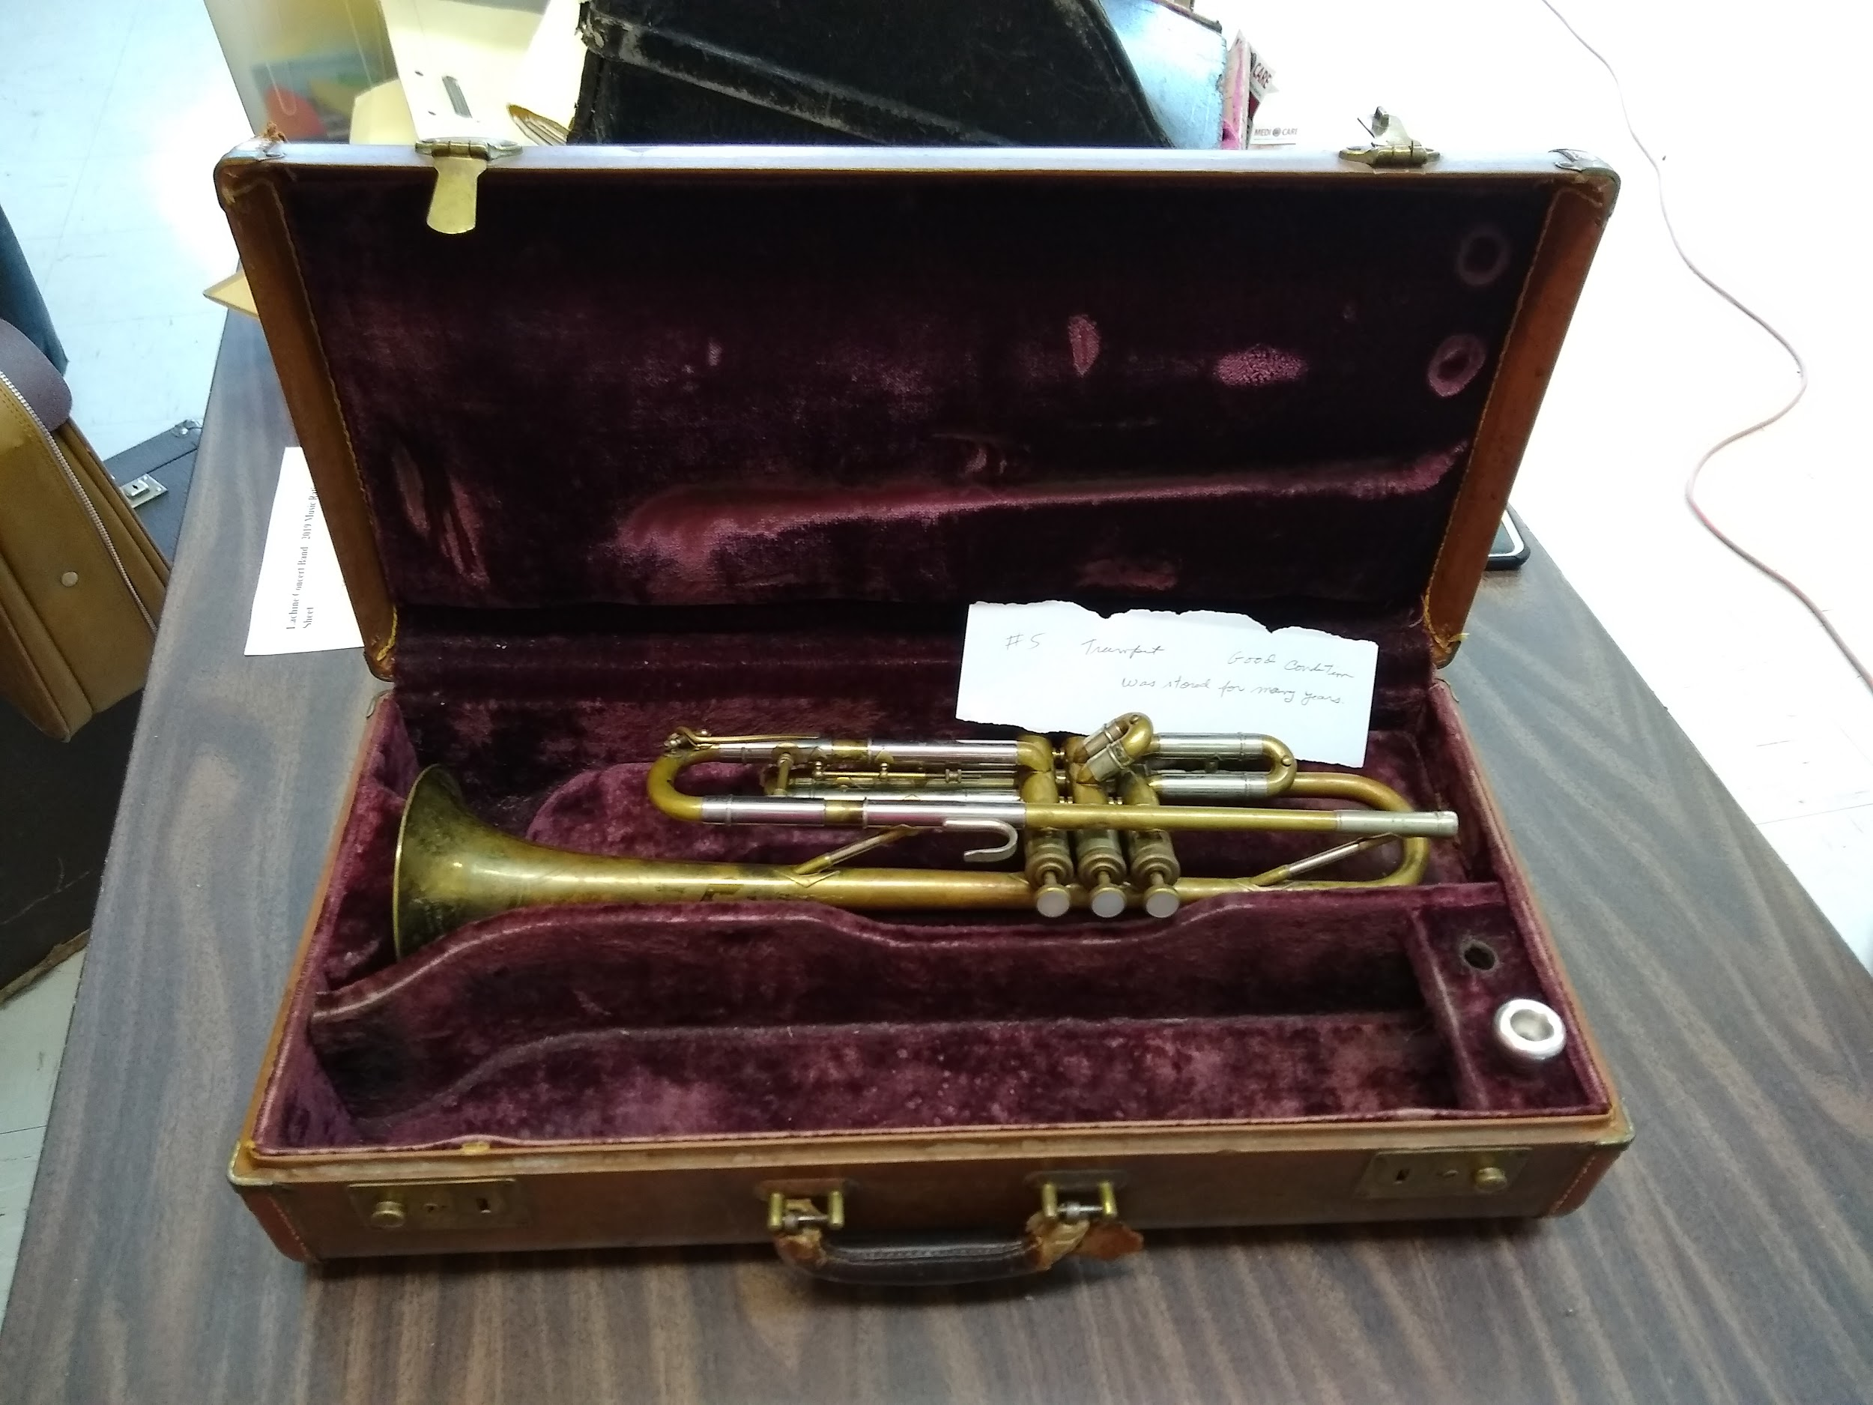 | Good | Sold  $60  Susan Bellamy
Tuba 8 | 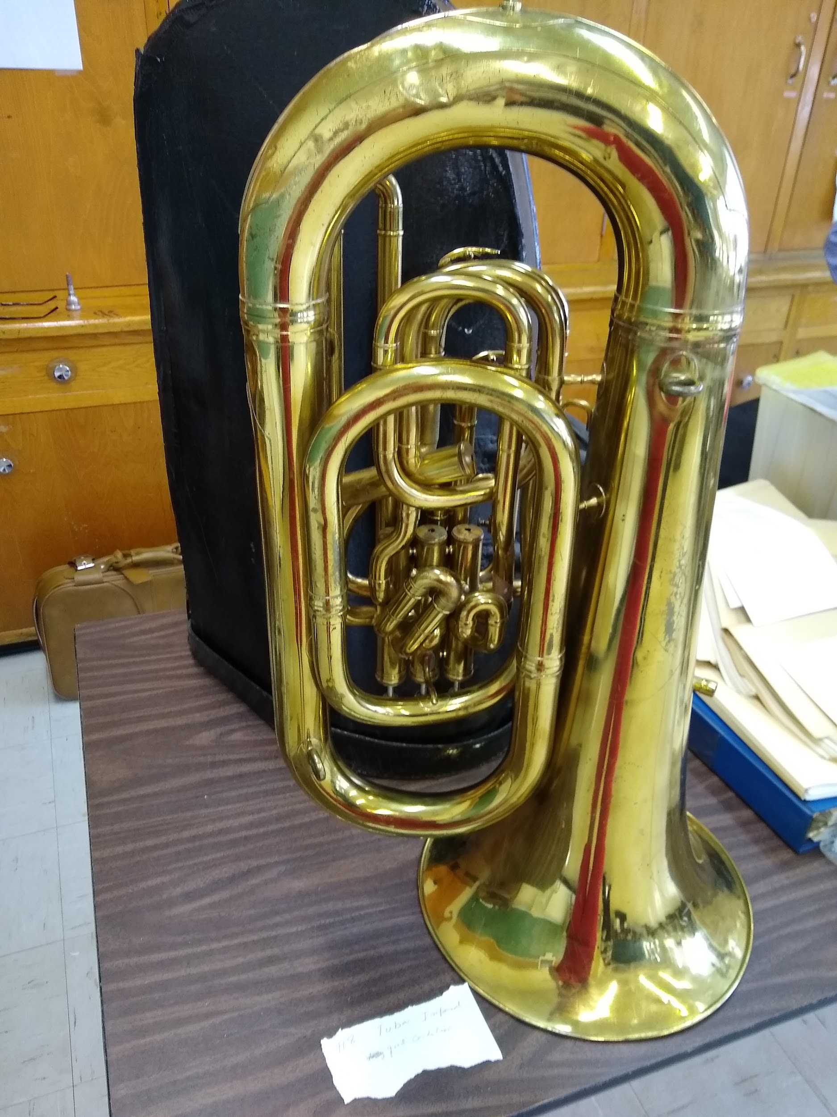 | Good | Sold  $200  Elizabeth Huyer
Tuba | 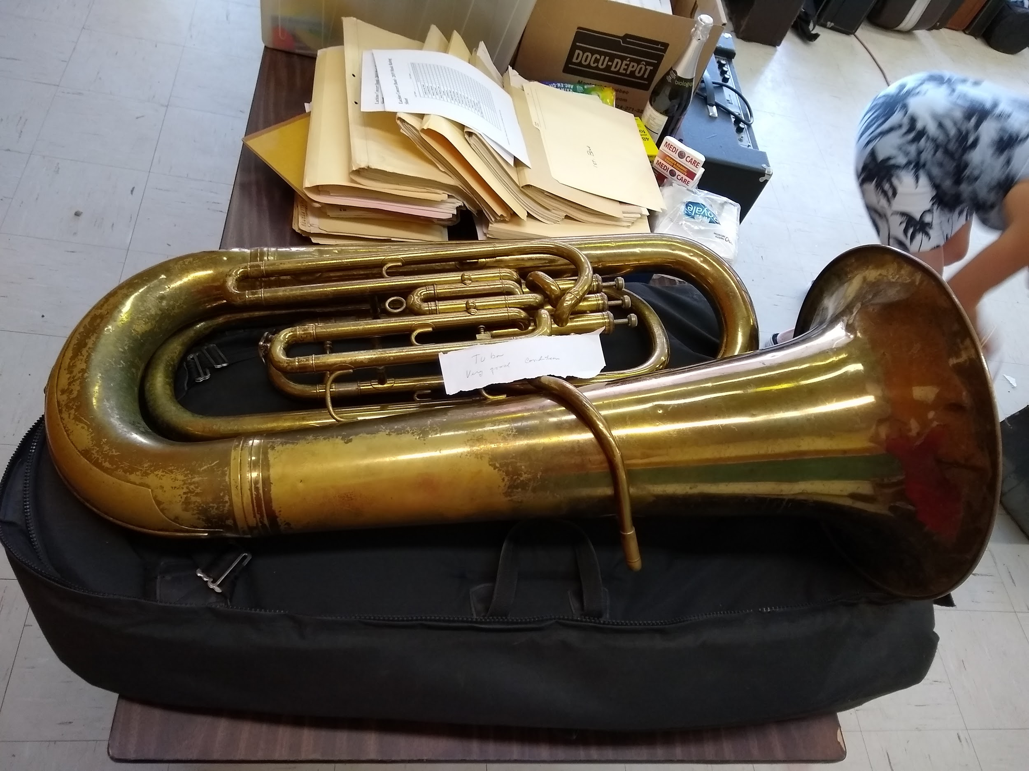 | Good | Sold  $200  Elizabeth Huyer

